Complete Details about interview and project explanation

AMS: Front End - Ec2

POC : Back End - Ec2

Database: Mysql 8.1 - RDS

Highly available + Highly Sclable + Security + Cost Optimization

Calculate application running time, Occording that we can create infrastructure

Domain Specific Infrastricture

Security : SG / ACL

High Available : Multi availablity Zone

Scalable: ASG

Ec2 -> Front End (Static Files) -> Backed(Php Application) -> RDS (DC/ DR)

DC-> Mumbai

DR-> North Virgenia

Route 53 -> Once DC down Traffic move to DR

Purchase Domain from Go Daddy or Route 53 -> Server in different Zone -> Load Balancer for balance load -> Static Content in S3.

Disastor Recovery:

Stategies available to your aws, 4 different DR Statagies, low cost and low complexity of making backup to more complex stategies using multiple active regions

Active and passive stategies use an active sites in onbe region and sites to host the workloads and server trafics, The passove sites are used for recovery and that was not share trafic untill active goes down.

Backup and restore

Pilot Light

Warm Stand by

Multi-site active/active

Backup and Restore : migrating against the dataloss and corruption

Region replication : Repliocating data from one to another

S3 DR: High Availablity

As an additional disaster recovery strategy for your Amazon S3 data, enable [S3 object versioning](https://docs.aws.amazon.com/AmazonS3/latest/dev/Versioning.html).

Object versioning protects your data in S3 from the consequences of deletion or modification actions by retaining the original version before the action.

 If you are using S3 replication to back up data to your DR region

S3: Security

Multi Factor Authentication: An additional layer of security that requires multi-factor authentication for changing Bucket Versioning settings and permanently deleting object versions.

DR statagies we can select bashed on business requirement,

If the new project ariving in your company

Cloud Architech -> Collect Requirement and Make designing -> Then provisioning resources

Start Project:

Need to purchase Domain from GoDaddy -> Purchased as **bootlabsmahi.shop ->** The need to purchase certificate for serve https request ->

GoDaddy -> ACM or CA (Certificate Authority – Its kind of bonofied certificate) -> Aws Route 53 -> Create Hosted Zone -> Exchage Name server to GoDaddy - > RDS -> Roles -> Ec2 Instance -> User Date

Application Architect :

Data Center: From one Region We can done set up couple of Availablity Zone

https://**bootlabsmahi.shop ->** Route 53 (Hosted Zone -> GoDaddy -> ) -> Load Balancer -> Ec2 (Php Application) deployment -> RDS (Applicatiom Data’s are stored in RDS)

The same we have do backup to S3 Bucket

Disastor Recovery : From another Region We can done set up couple of Availablity Zone

https://**bootlabsmahi.shop ->** Route 53 (Hosted Zone -> GoDaddy -> ) -> Load Balancer -> Ec2 (Php Application) deployment -> RDS (Applicatiom Data’s are stored in RDS)

Step1: Purchase one domain from GoDaddy else Aws Route 53

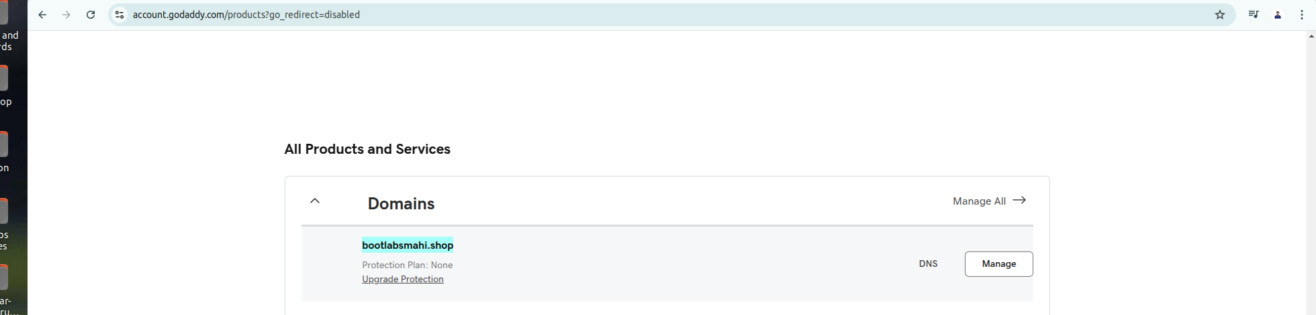

Step2: Create Certificate Manager (Request a certificate bashed on my Domain)

Aws Certificate manager handles the complexity of creating, Storing and reneing public and private SSL / TLS X509 certificate and keys that protect your aws websites and applications.

Purchase our certificate directy from AWS or Third party certificate in to ACM.

There is two type of certificate they will provide

Public Certificate : ACM certificate for all the browsers (By Default)

Private Certificate : you can export your private Certificate Authority you can use anywhere in internally.

Selfsigned Certificate

ACM Provides single domain name in to multiple domain names

If we need to protect un limited no of domain means aws recommend Wildcard certificate.

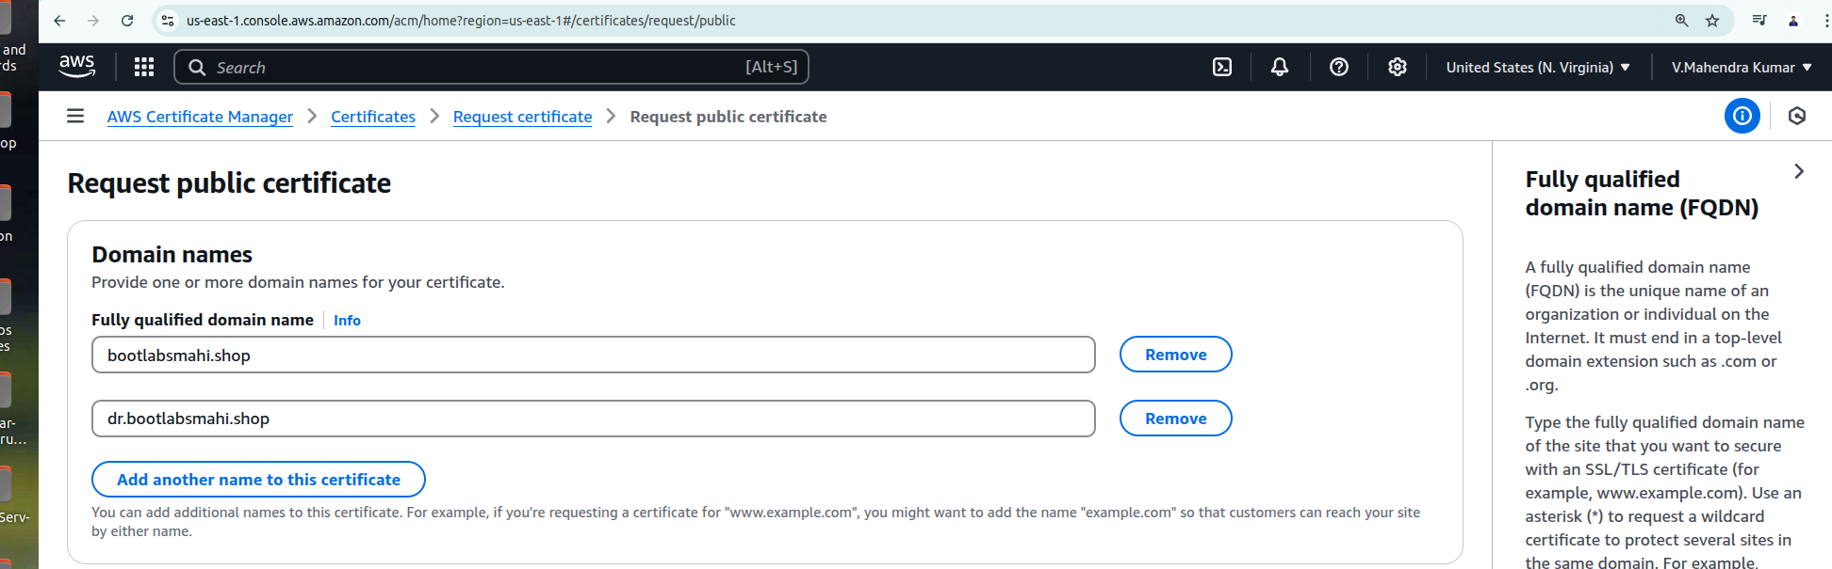**OR**

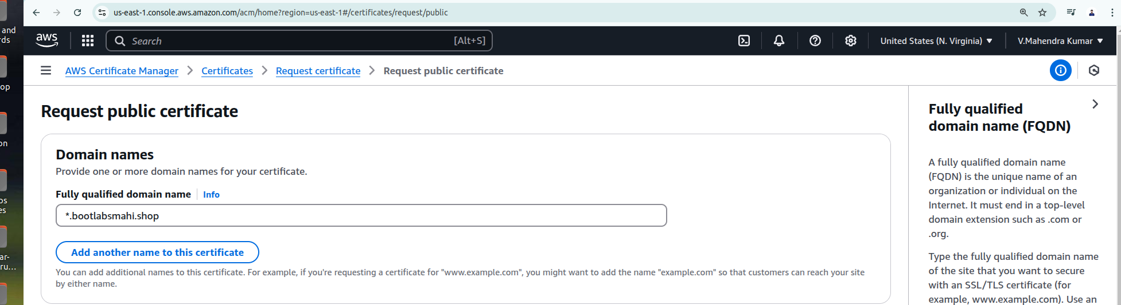

Type the fully qualified domain name of the site that you want to secure with an SSL/TLS certificate (for example, www.bootlabsmahi.shop). Use an asterisk (*) to request a wildcard certificate to protect several sites in the same domain. For example, *.bootlabsmahi.shop protects www.bootlabsmahi.shop. site.bootlabsmahi.shop, and images.bootlabsmahi.shop.

*.bootlabsmahi.shop

**Domain Validation Method:**

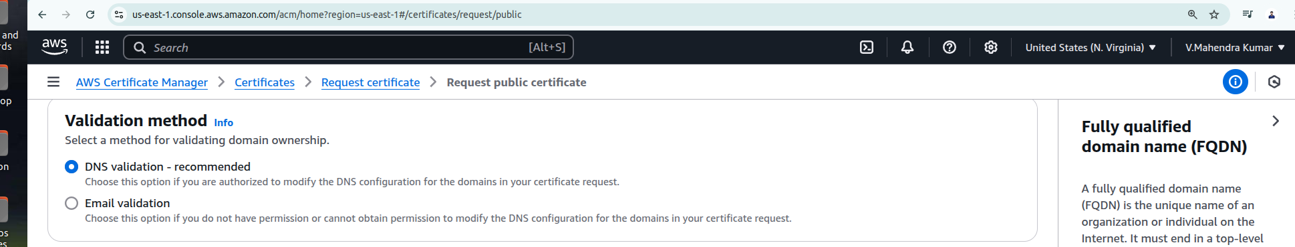

**Key Algoritham:**

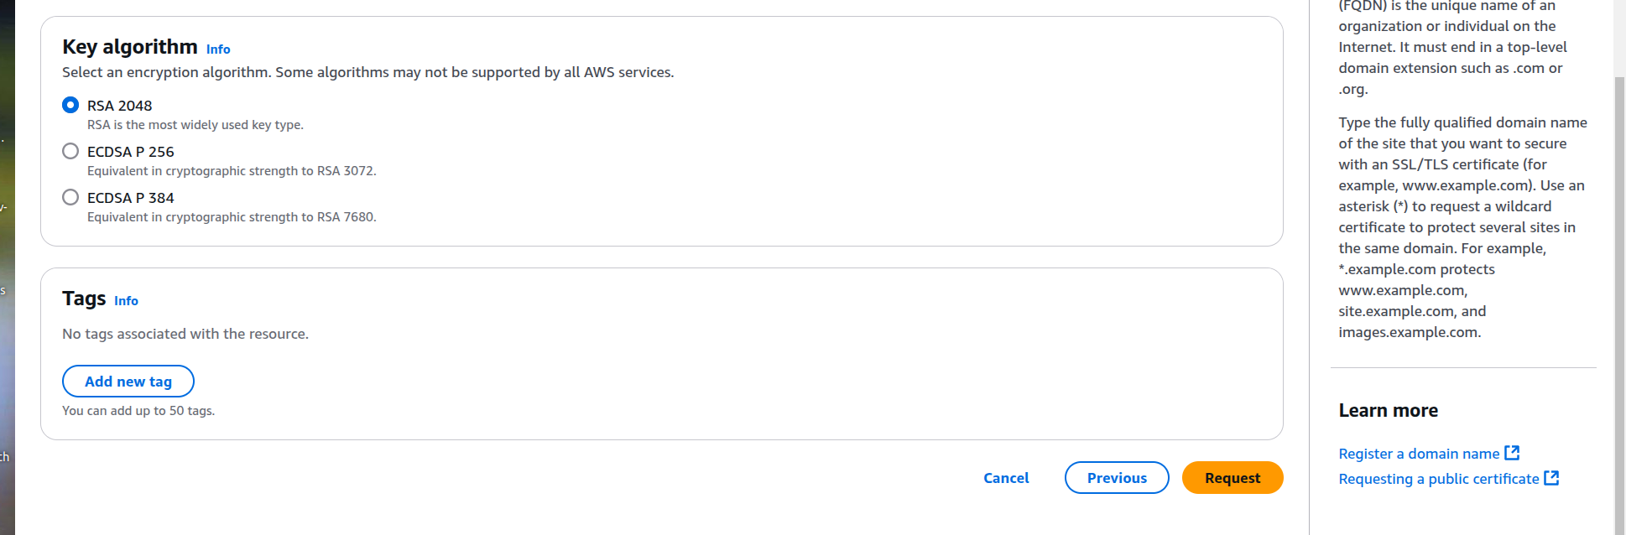

**After request :**

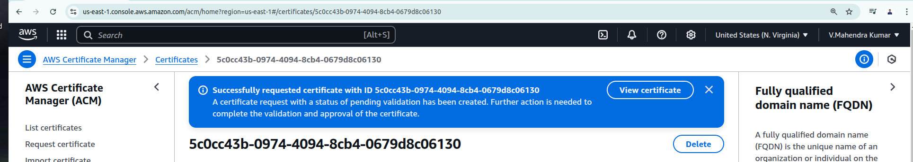

**Validating domain ownership**

Before aws CA certificate authority can issues a certificate for your sites aws ACM must prove that you own or control all of the domain names that specify in your request.

**Notes: Aws ACM should valildate applies only the public trusted certificate issues by ACM, ACM does not validate domain ownership for the imported certificate or the certificate validated by private..**

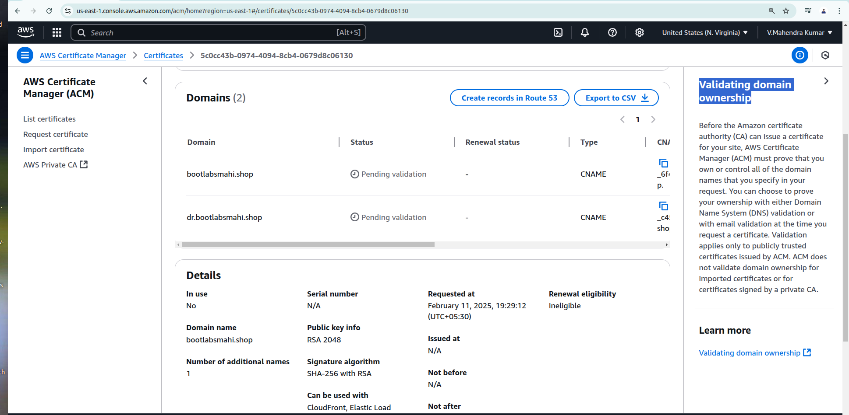

**Step3: Route 53: Here we need to create records for purchased domain name.**

**Step1(a) ; Create Hosted Zone: When you want to use route 53 to route internet traffic for your domain or route internet traffic for your VPC. Then you can create a record in your hosted zone for the domain name bootlabsmahi.shop.**

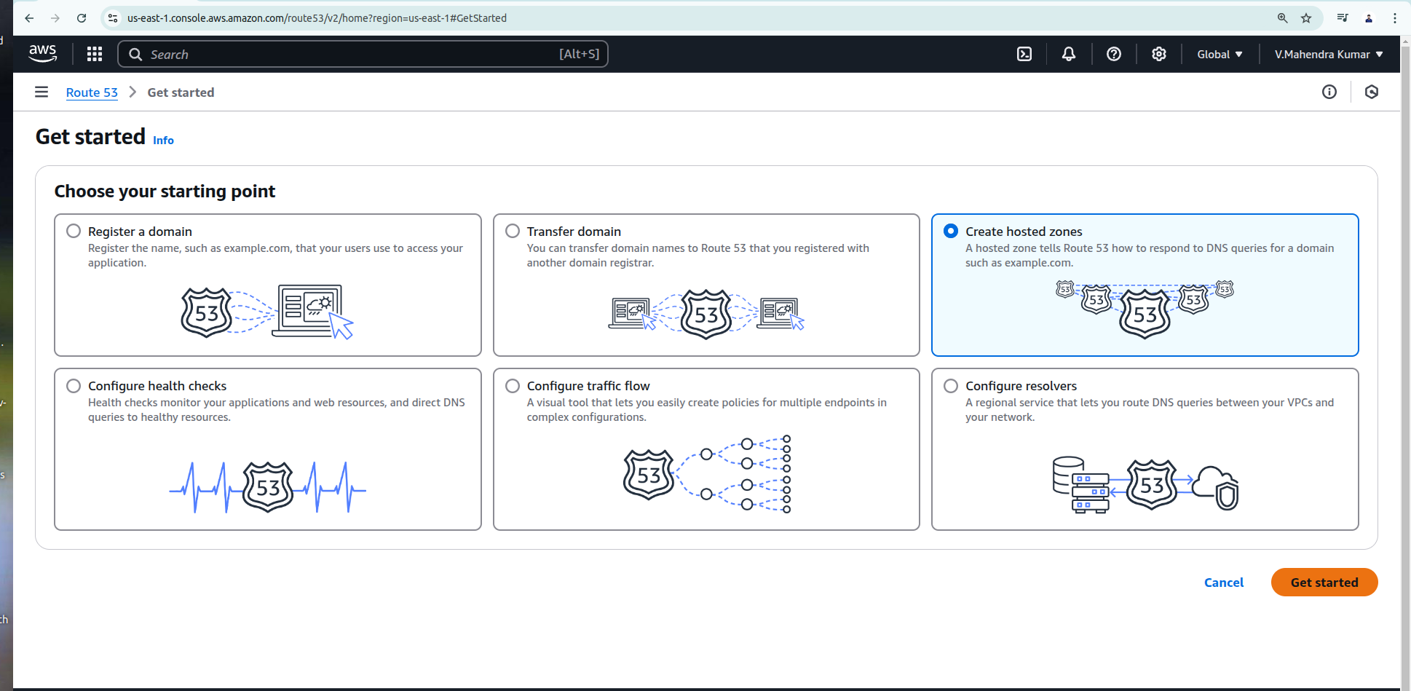

**Note: When your register domain in Route 53, A public hosted zone automatically created. You can also create a new hosted zone for sub domain.**

**If you want to route traffic to your vpc you create a private hosted zone for your domain and associated a vpc to it.**

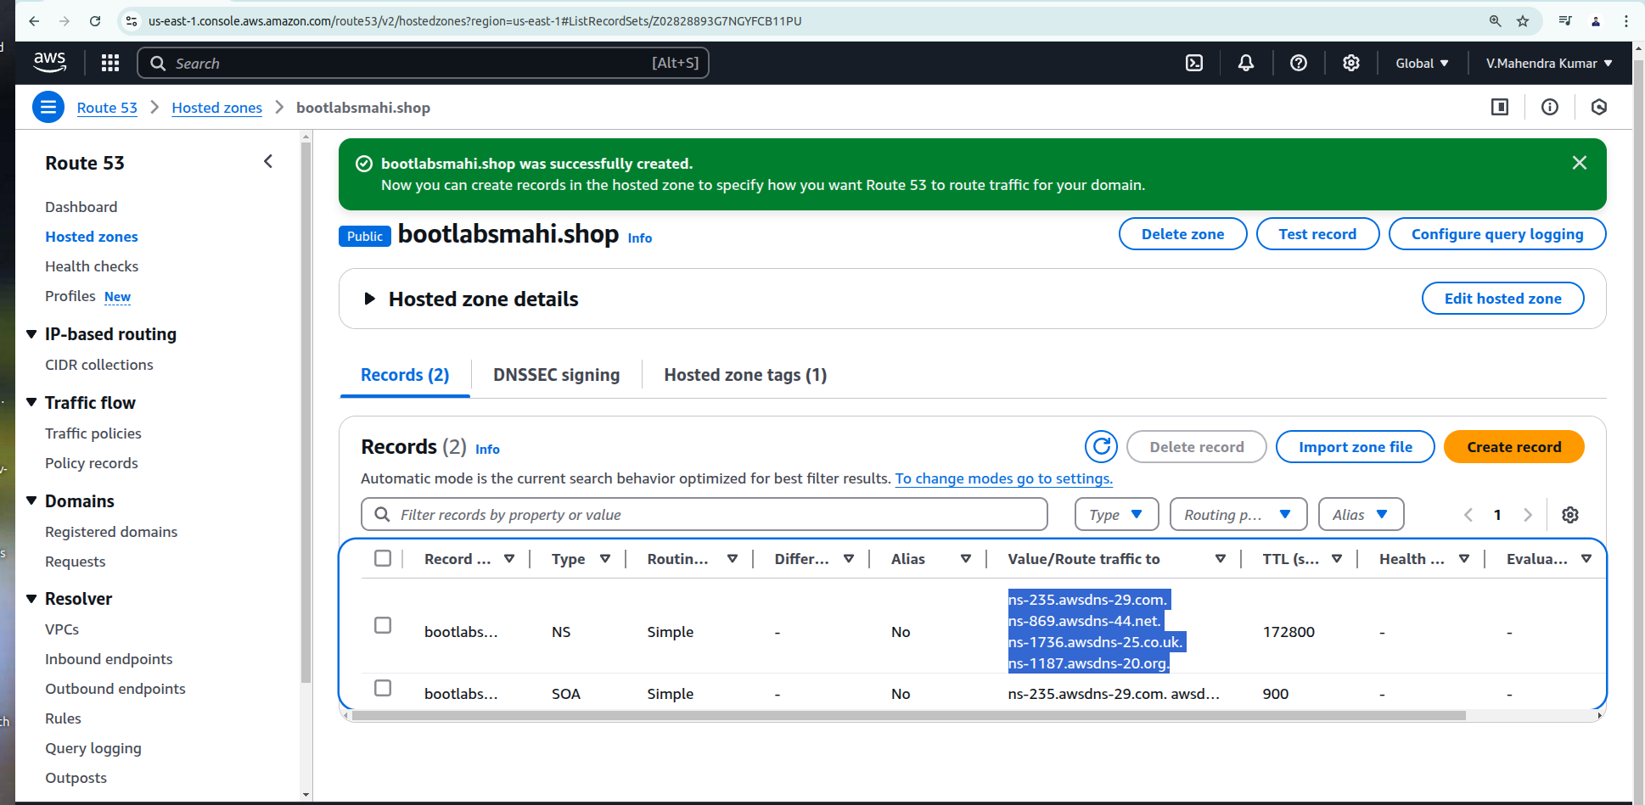

**ns-235.awsdns-29.com  
ns-869.awsdns-44.net  
ns-1736.awsdns-25.co.uk  
ns-1187.awsdns-20.org**

**We need to exchage above four name servers in to goDaddy, Because of user reqest comes to route 53 -> and Route 53 route traffic to -> Hosted zone -> Hosted zone route request to GoDaddy by using this nam server.**

**Go to your profile -> My product -> Then select purchased domain -> Click manage -> Then left side Domain -> Manage DNS -> Then select Name Server -> Then change record s.**

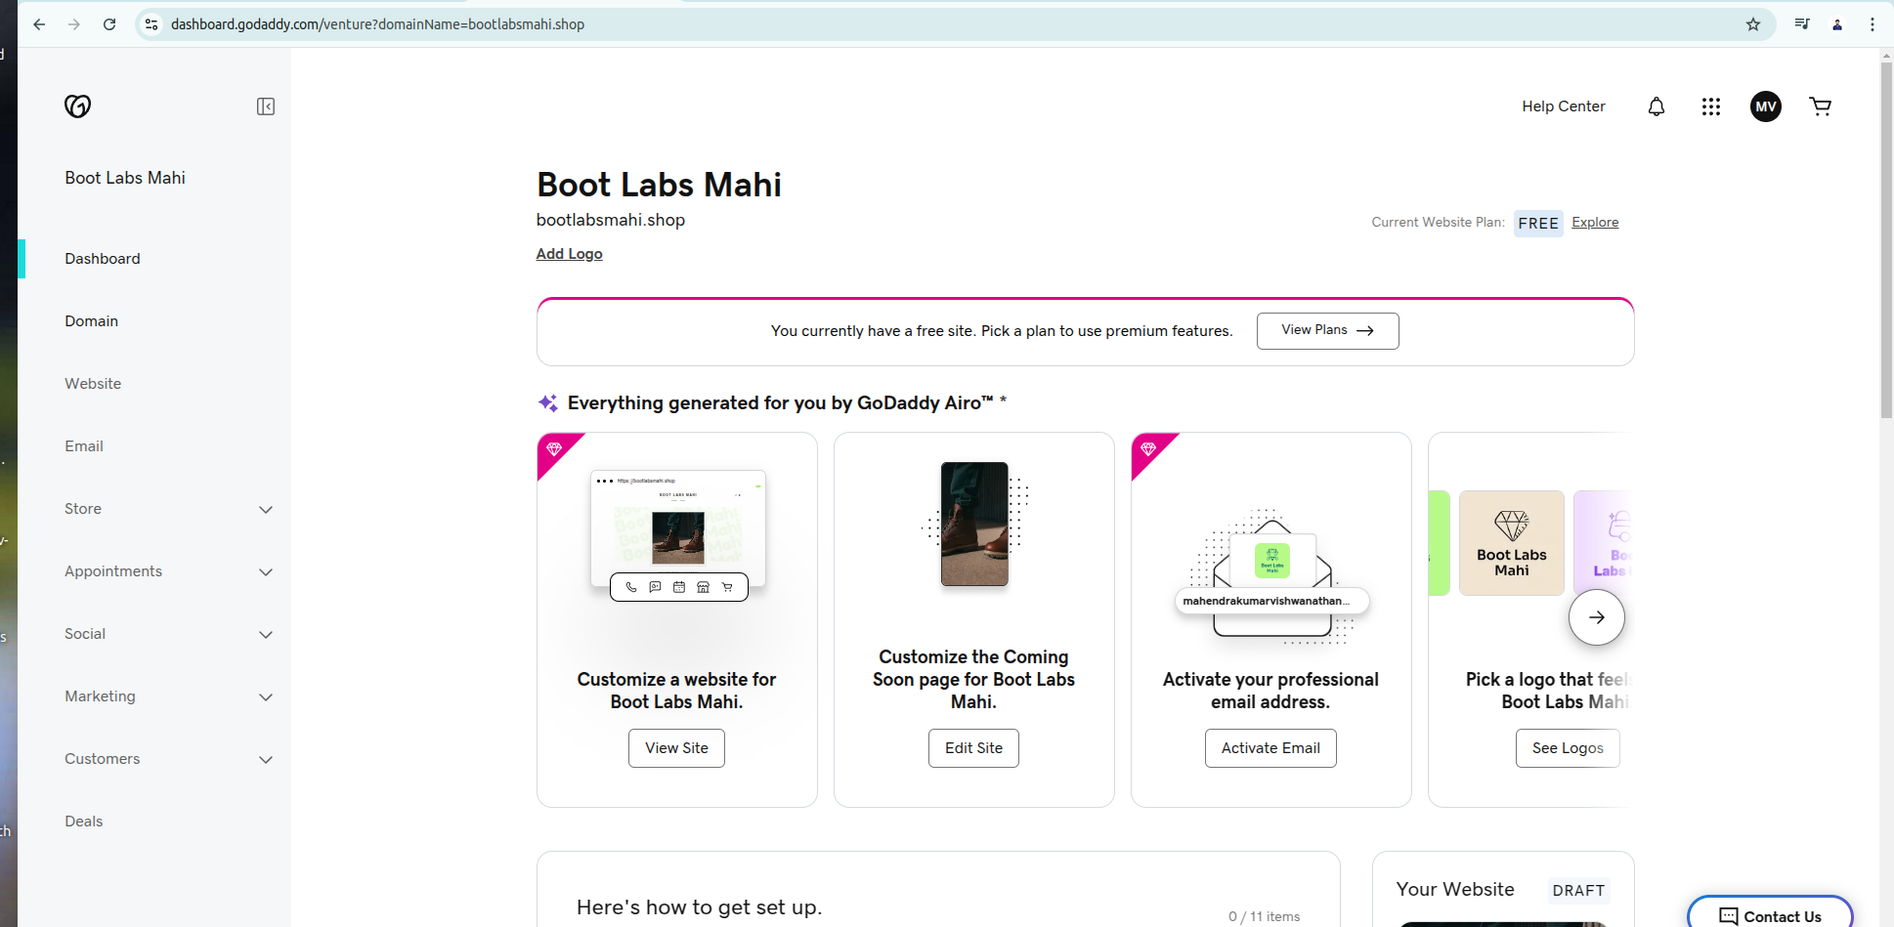

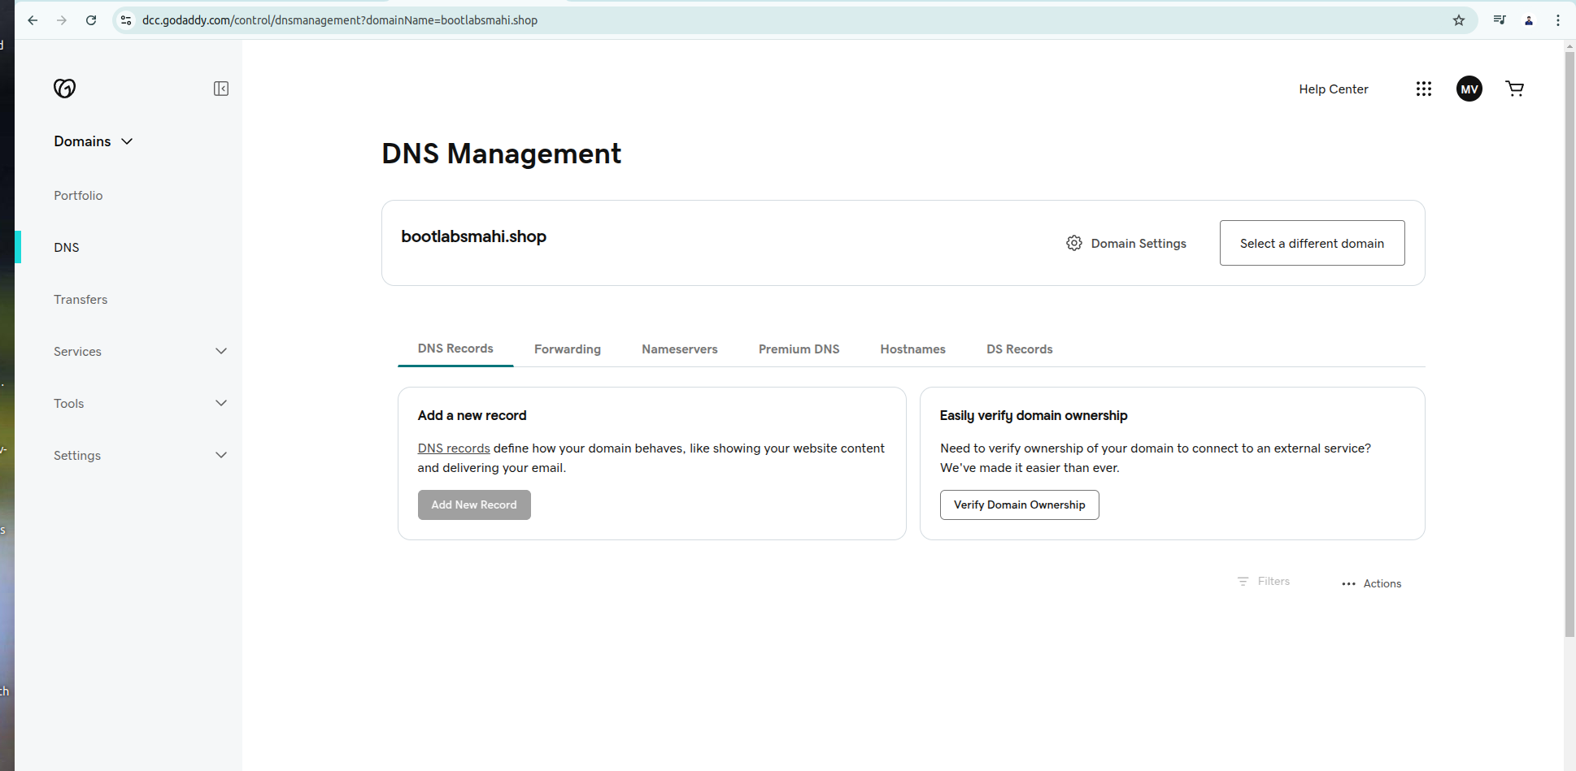

**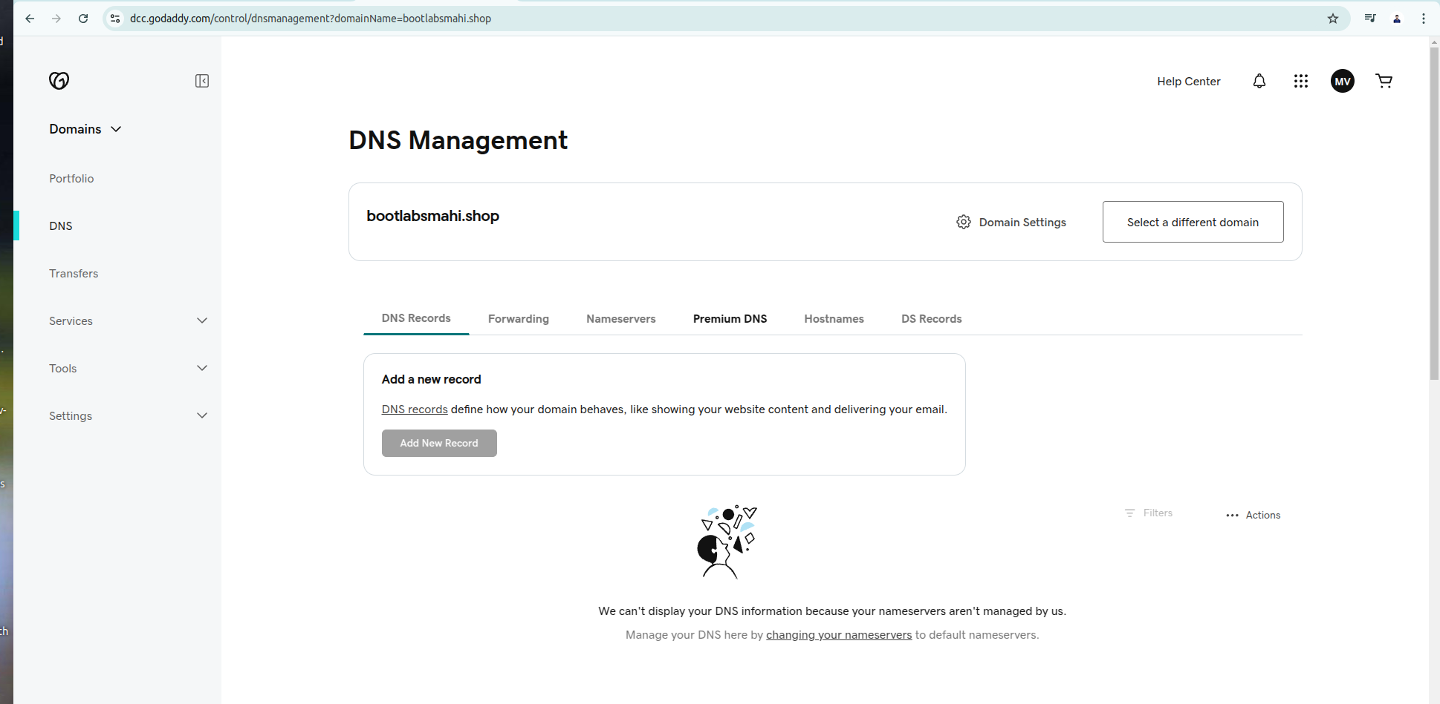  
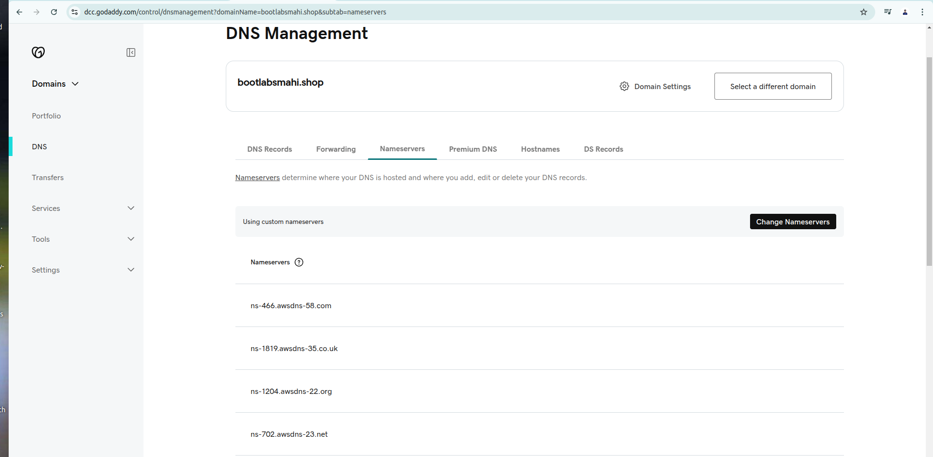**

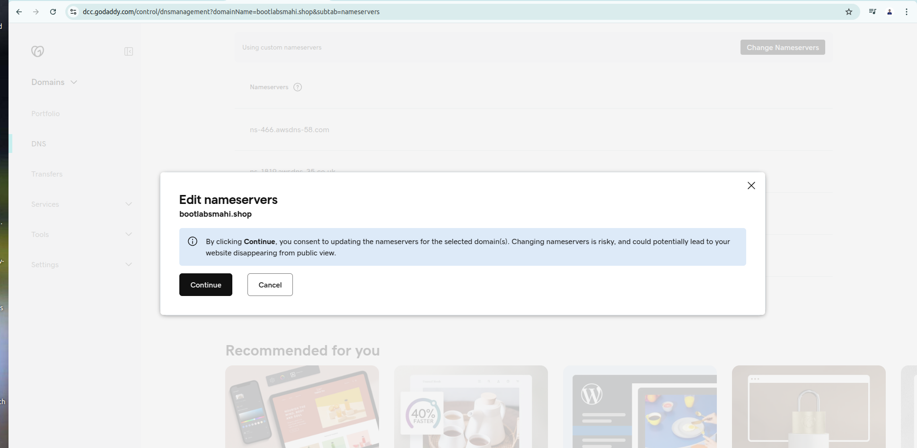

**Now create Records in route 53: To set record from ACM in to route 53**

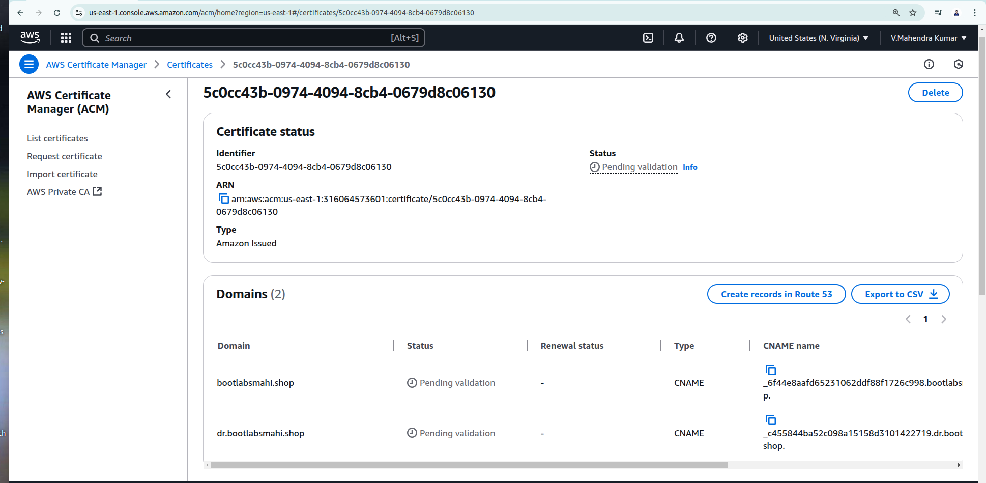

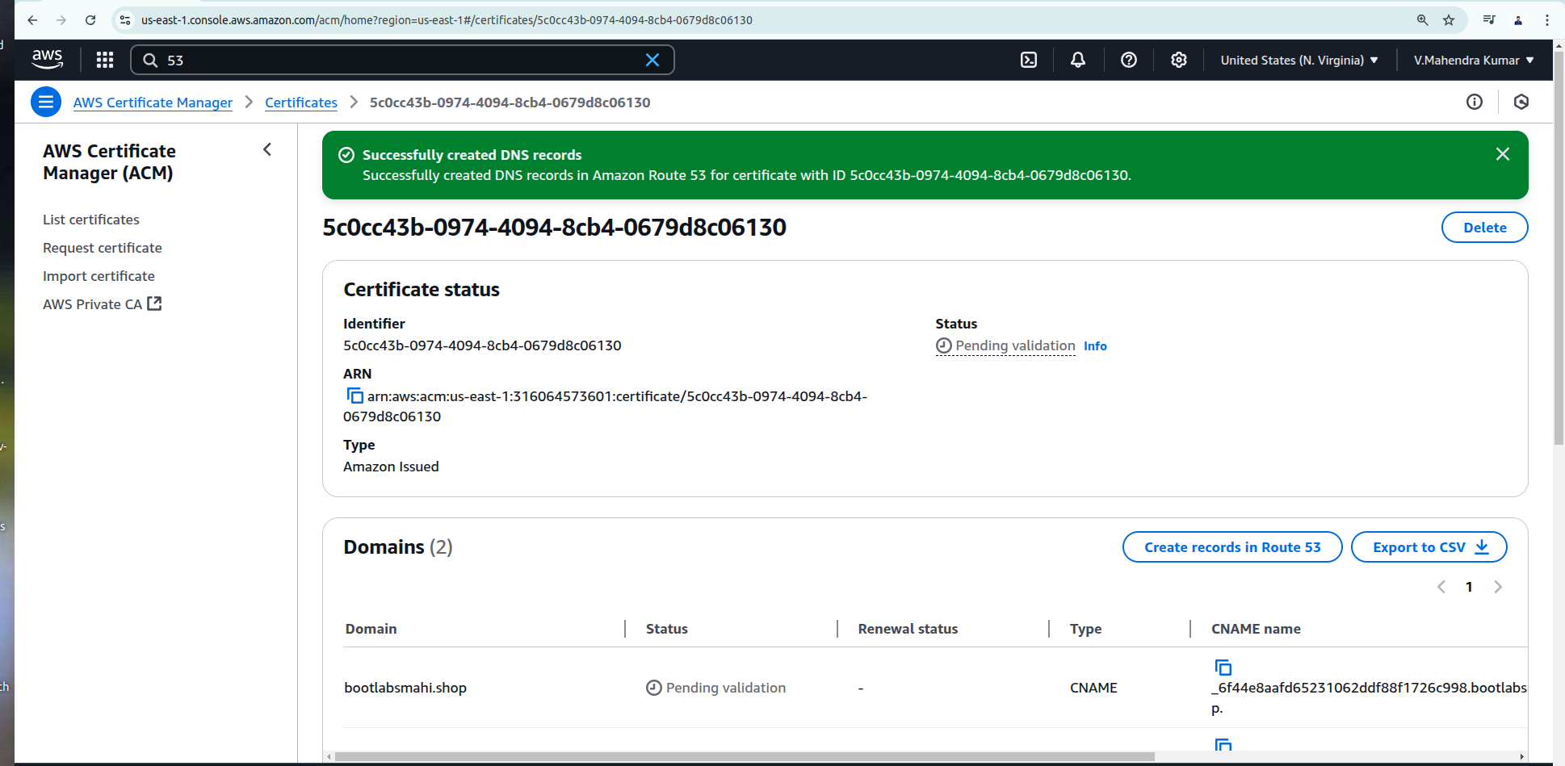

**Before Record Set create from Acm to Route 53:**

**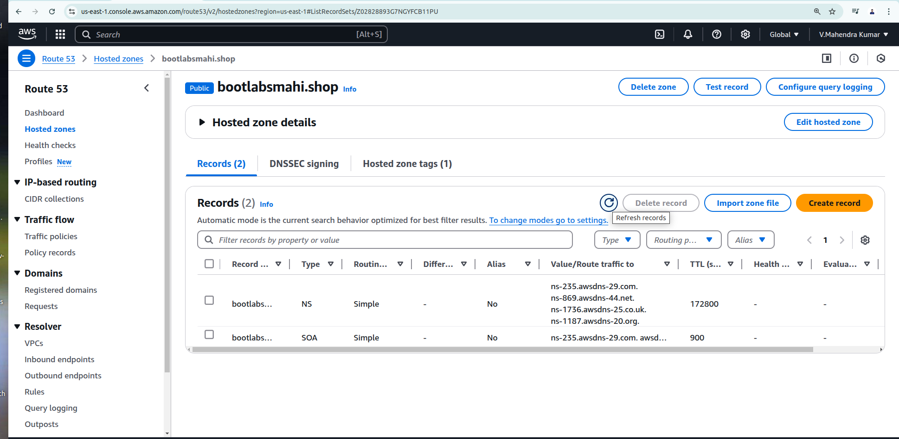  
  
After Record Set create from Acm to Route 53: Added Cname record.  
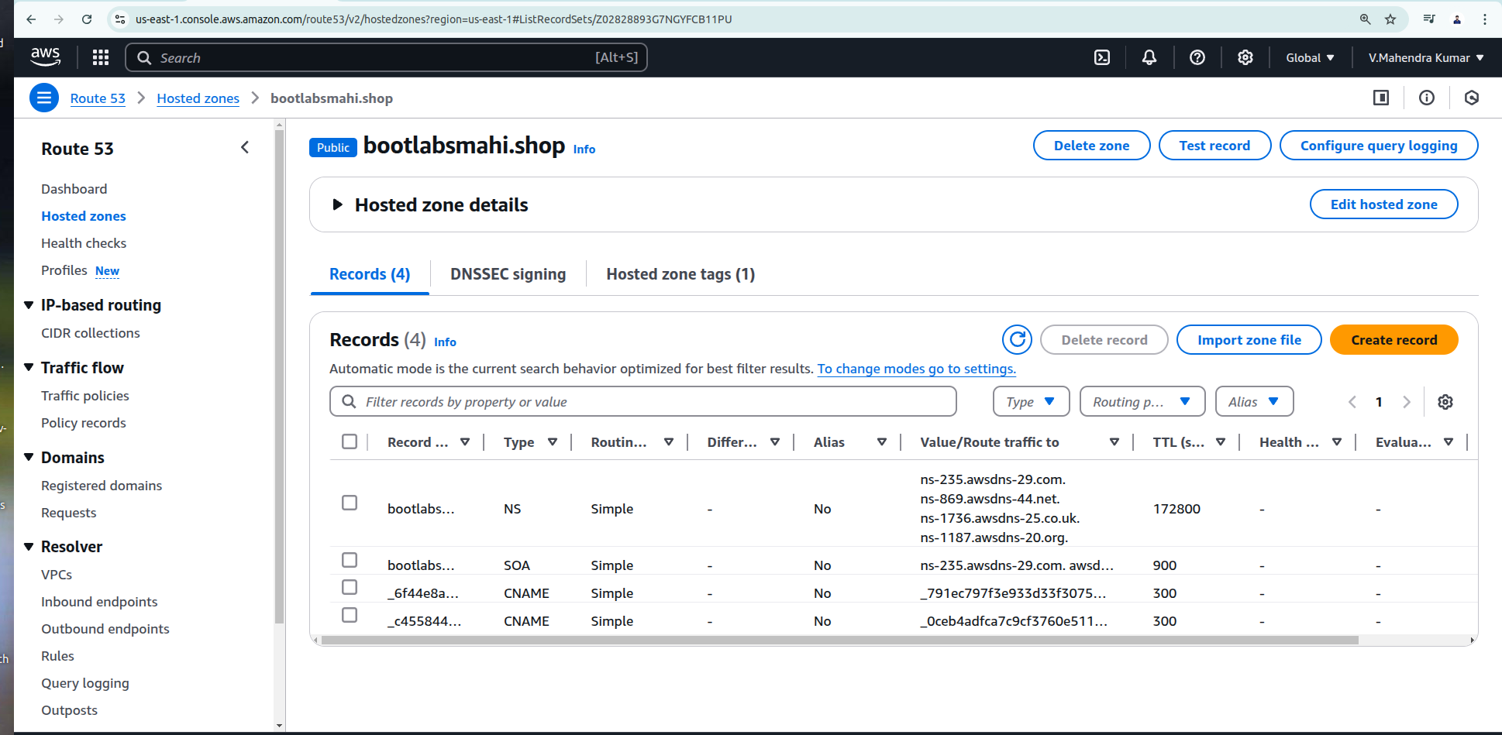**

**Steps 3: Now need to create RDS,**

We need to create couple of RDS for DC and DR

Before create RDS we need to create Default or owned Vpc.

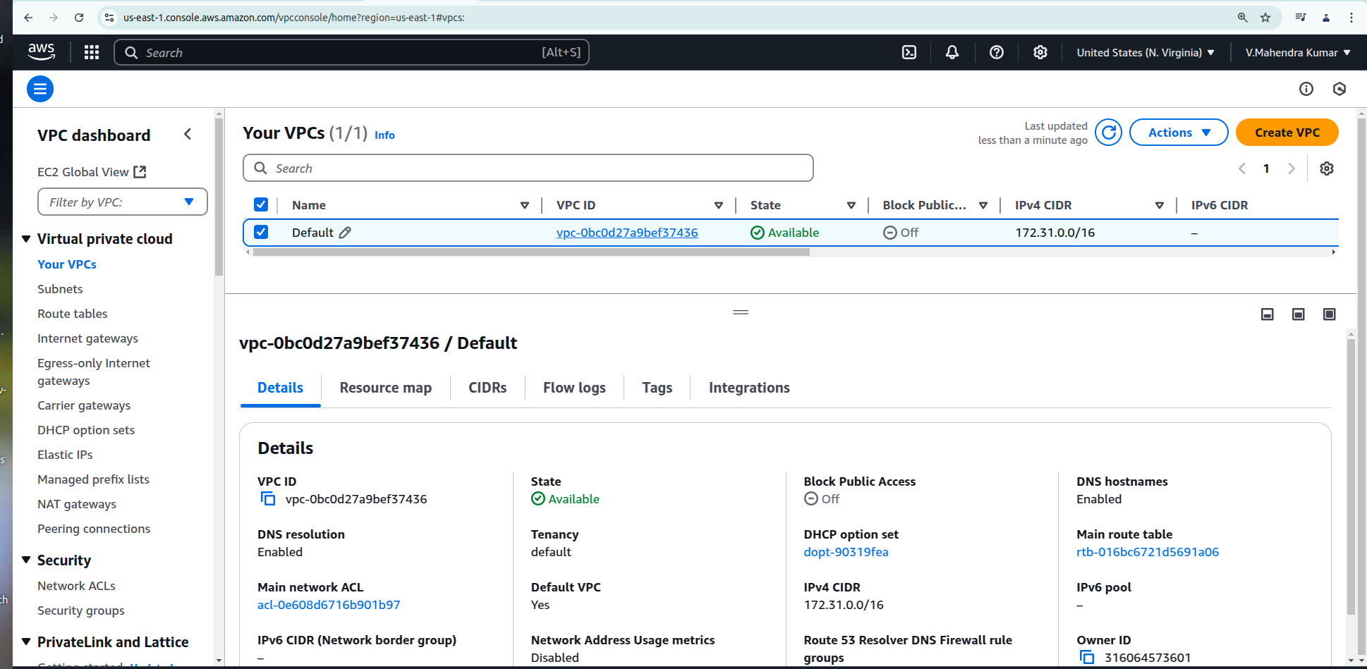

**Then need to create Security Group: Allow all traffic from inbound rule.**

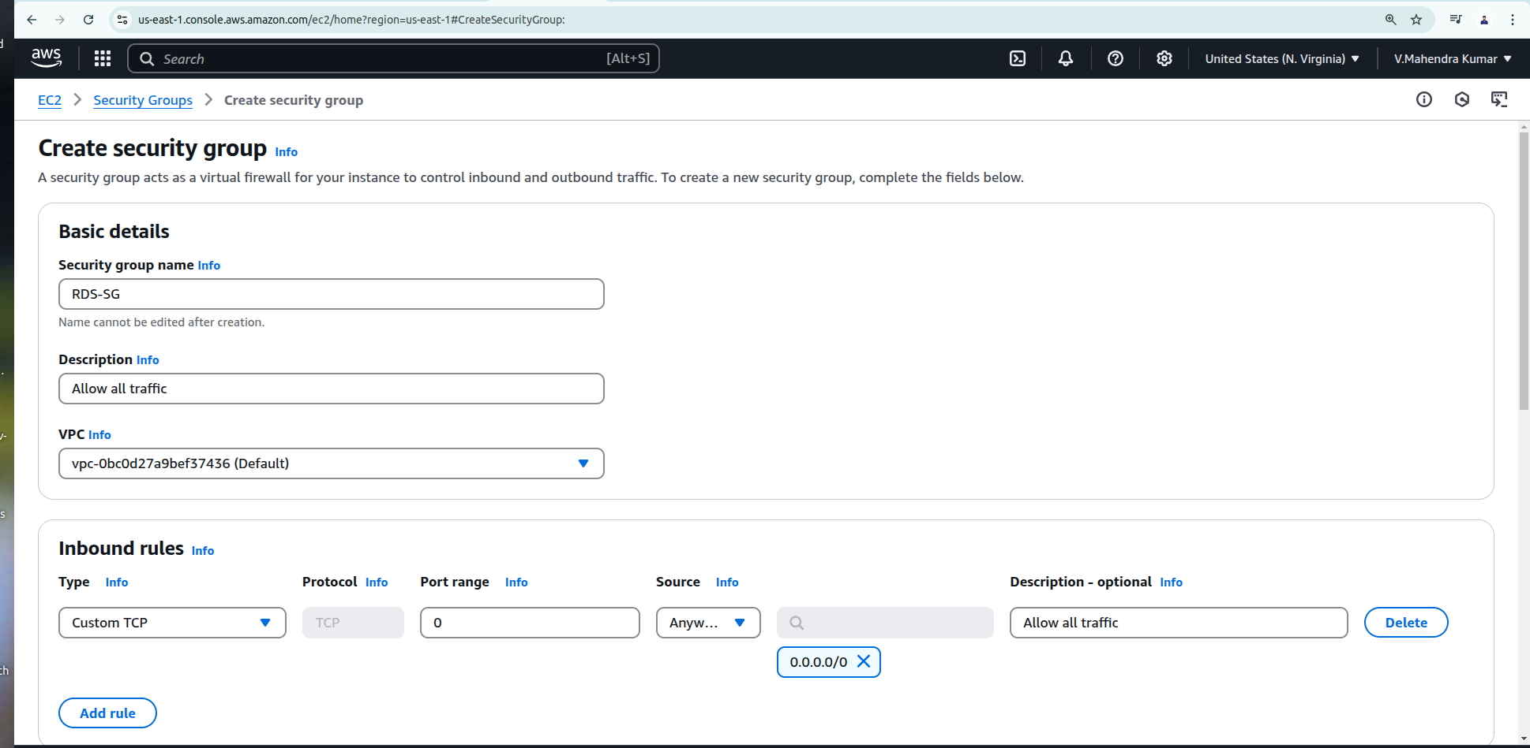

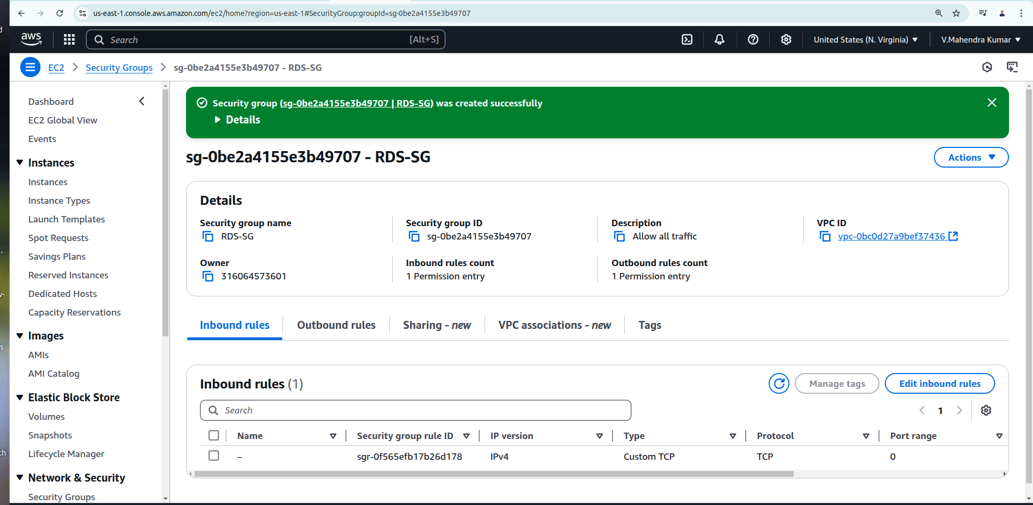

**Security Group for Both production (DC) and Disastor Recovery (DR)**

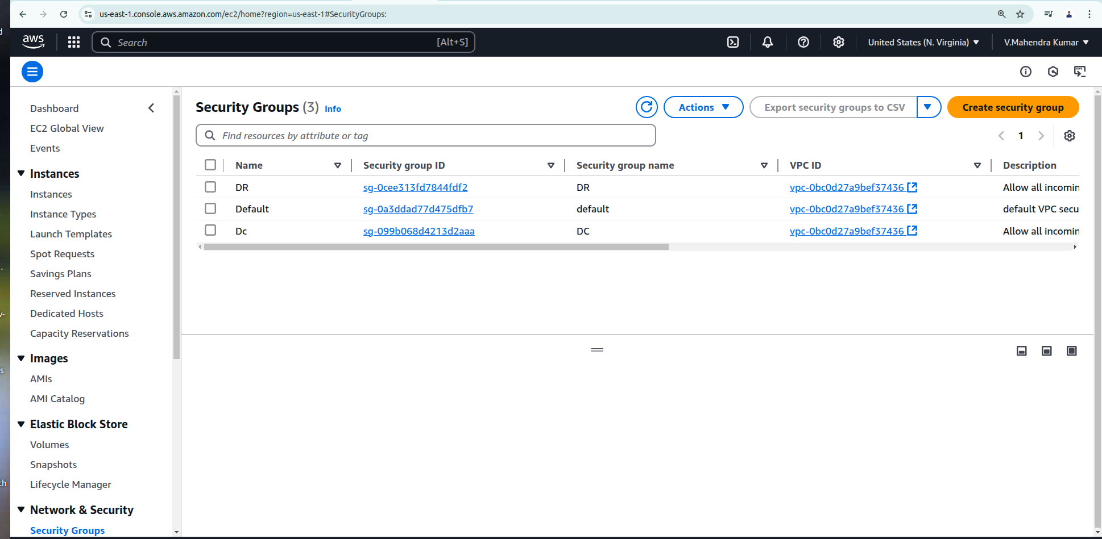

**Then create subnet group for RDS instance: Collection of subnets used to designate cluster in an Amazon vpc, When creating a cluster you can specify subnet group.**

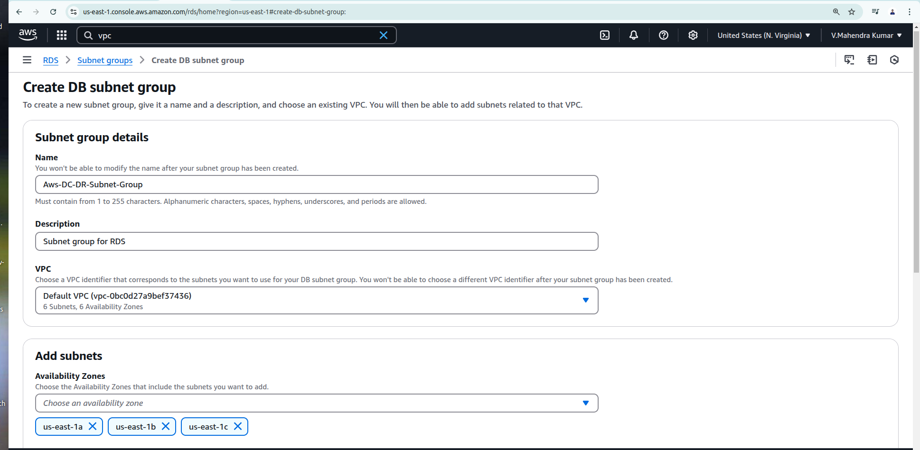

**Selected multiple Availablity zone for RDS high availablity**

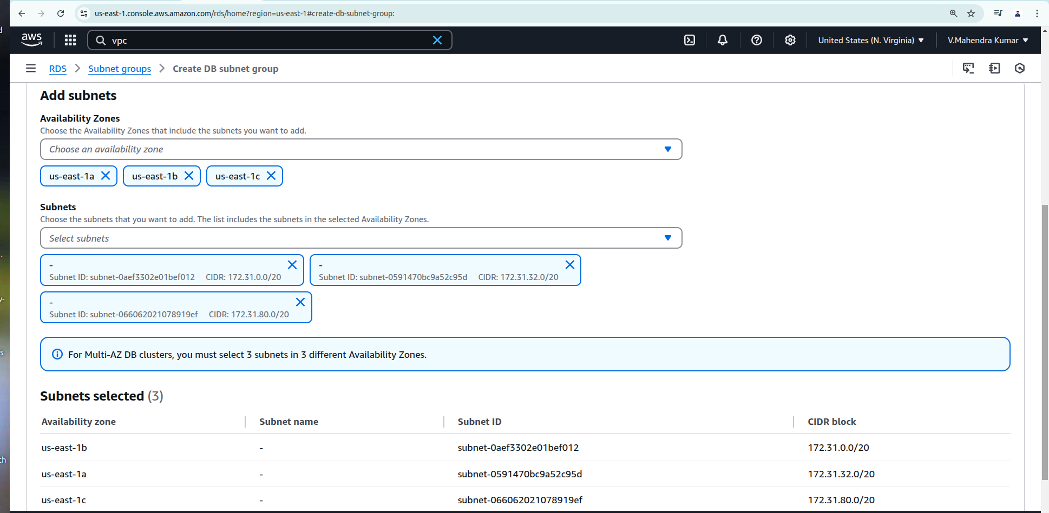

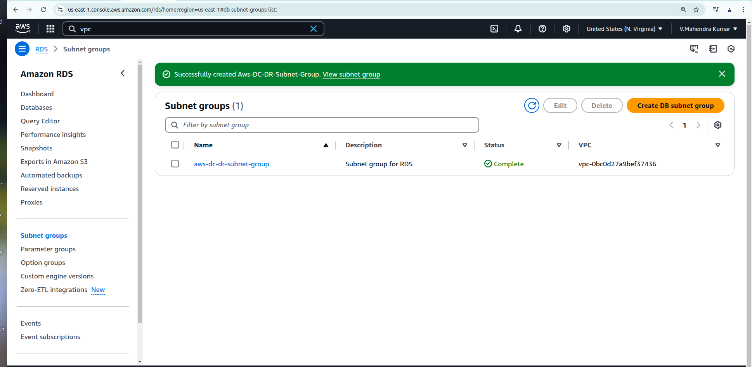

**Then Need to create two Database for production (DC) and DR:**

**DB_Name : DCDB**

**User_Name : admin**

**Password :** [**Mahende**](mailto:Mahender@1029)**r**

**DB_name : DRDB**

**User_name: admin**

**Password:** [**Mahender**](mailto:Mahender@1029)

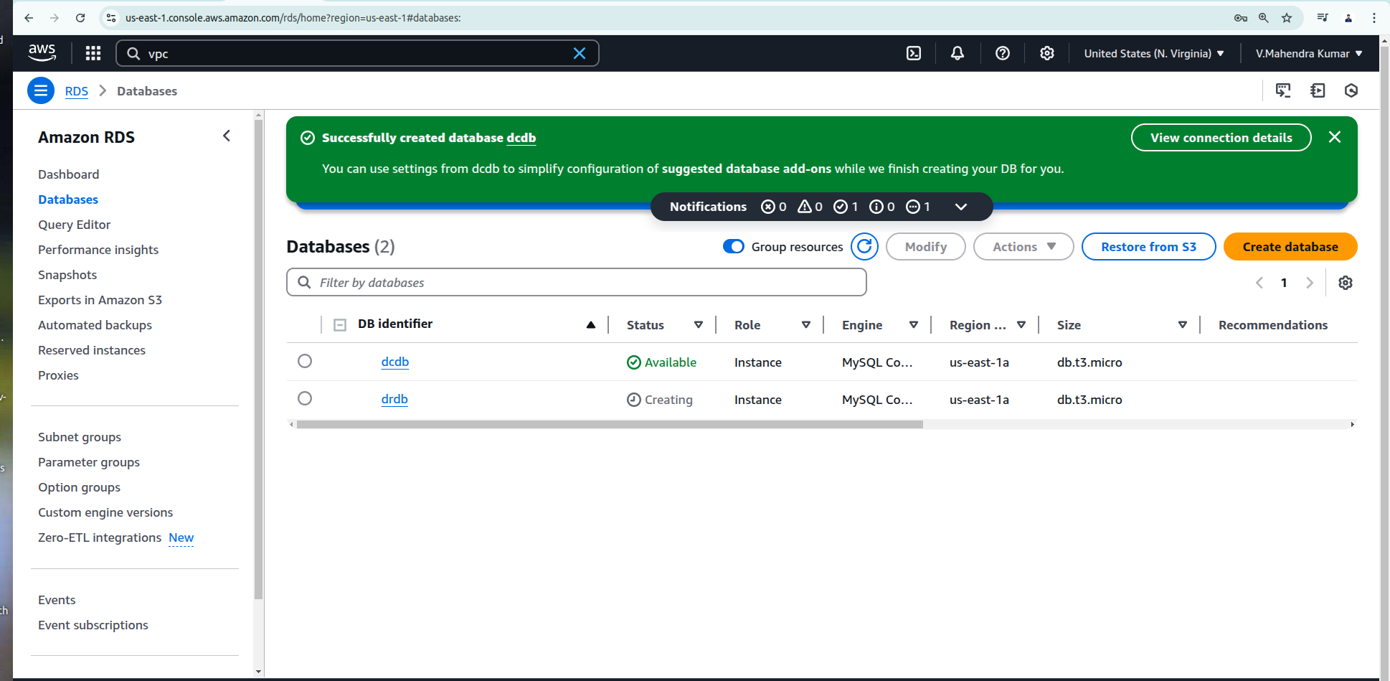

**Create IAM role with administrator access.**

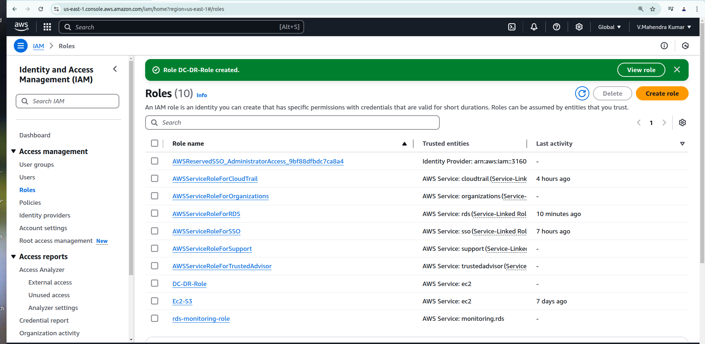

**Then create couple of Ec2 instance for deploy our application (One for DC and Another one for DR)**

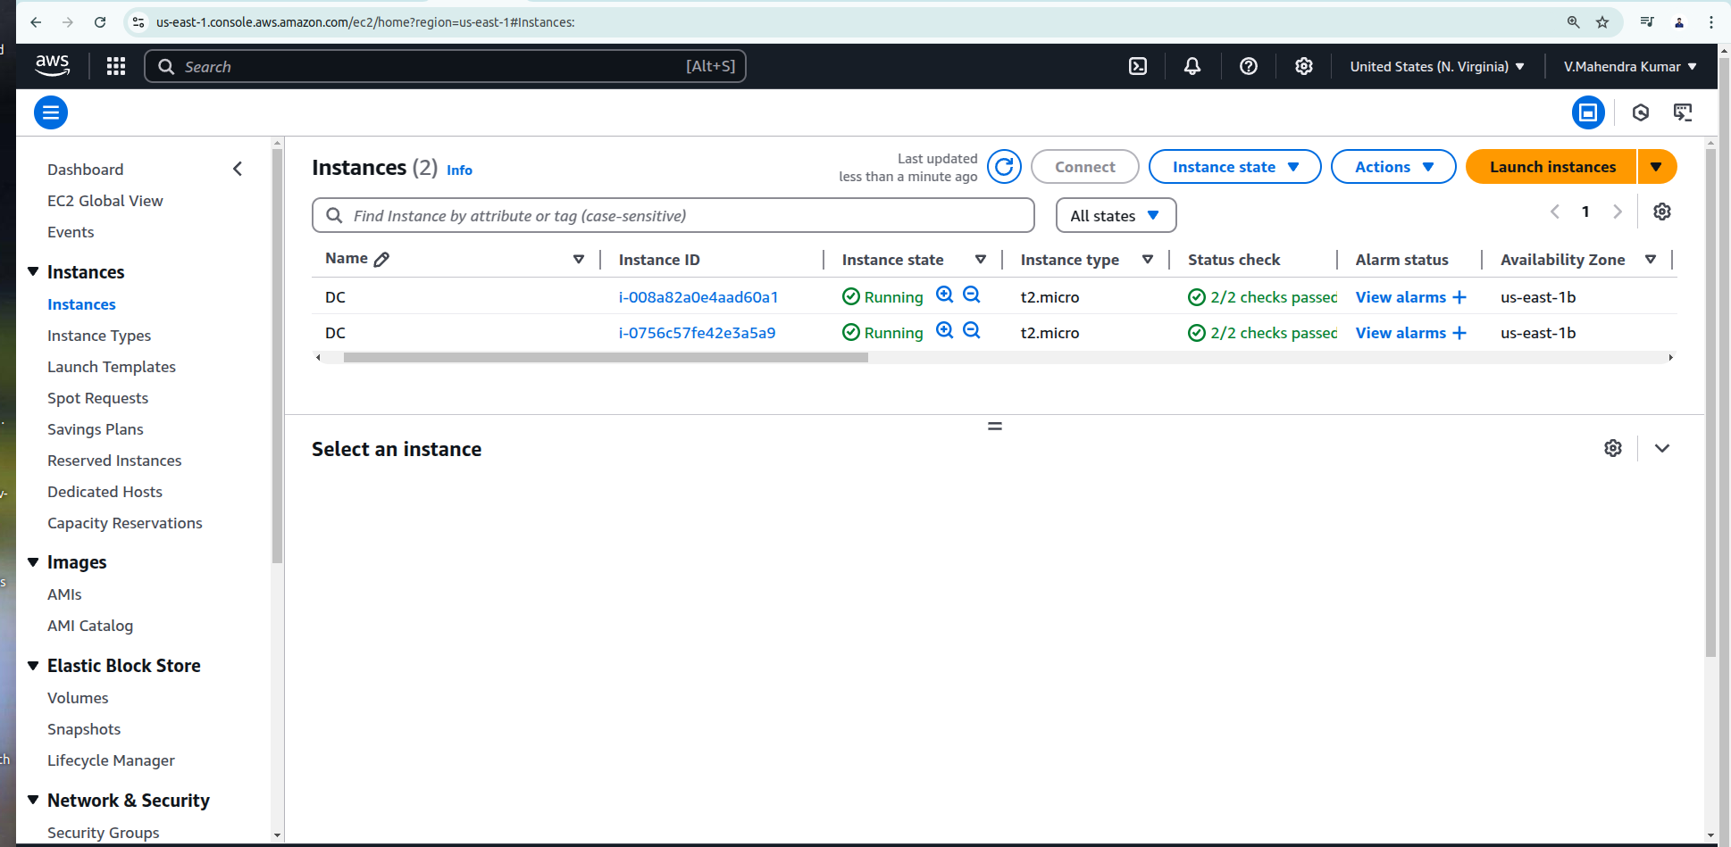

**Check application from both DC and DR server’s.**

**Instance 1: 3.238.138.135**

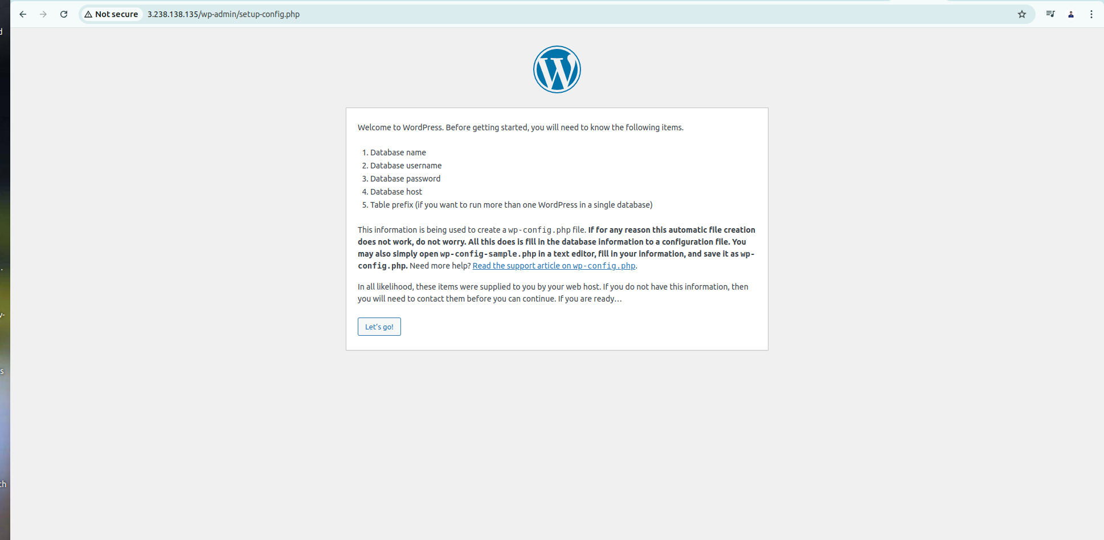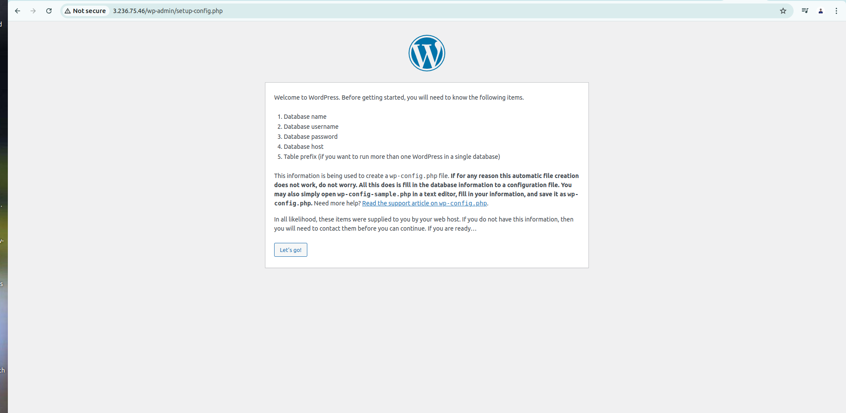**Instance 2:** 3.236.75.46

**Instance 1: 3.238.138.135**

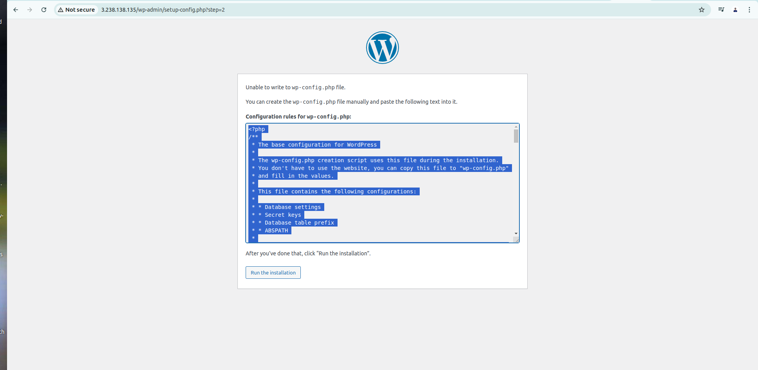

**Instance 2: 3.236.75.46**

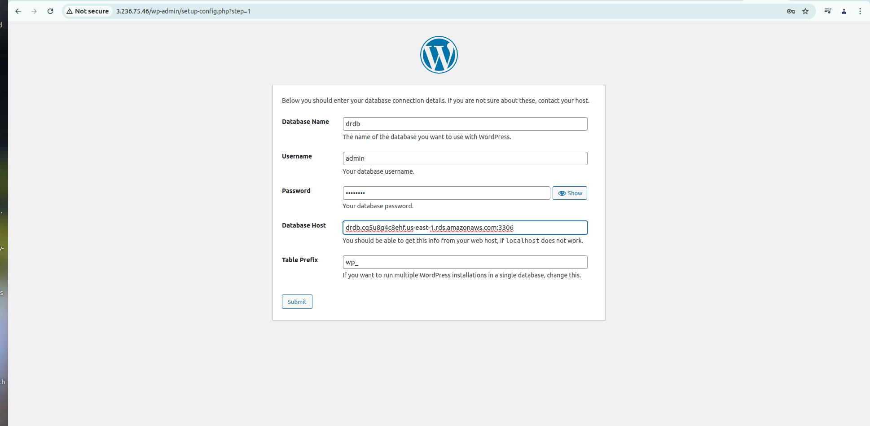

**From the DR instance while connect with the DB using endpoint and credentials am facing 504 Gateway Timeout error.  
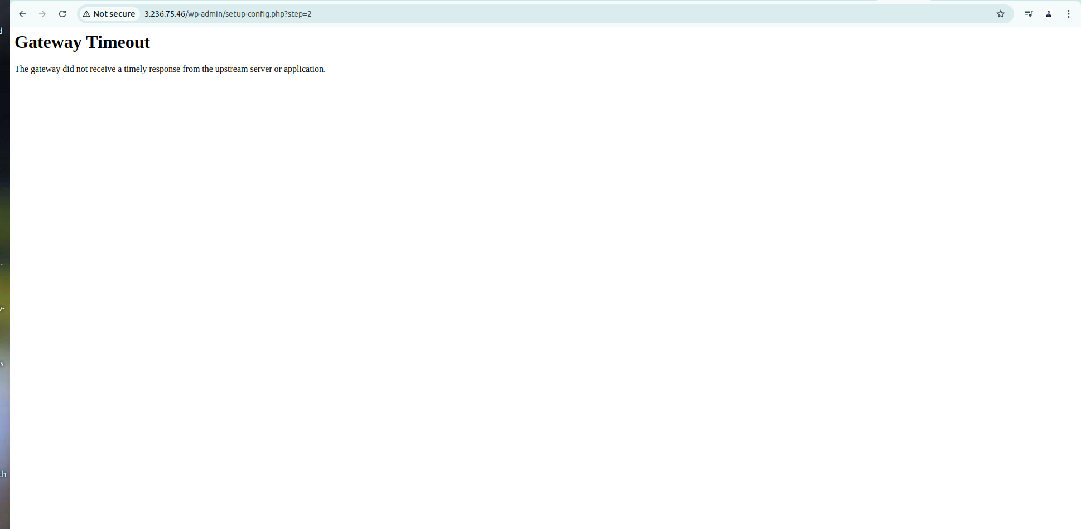**

**This error happend because of missing inbound entry from security group which is 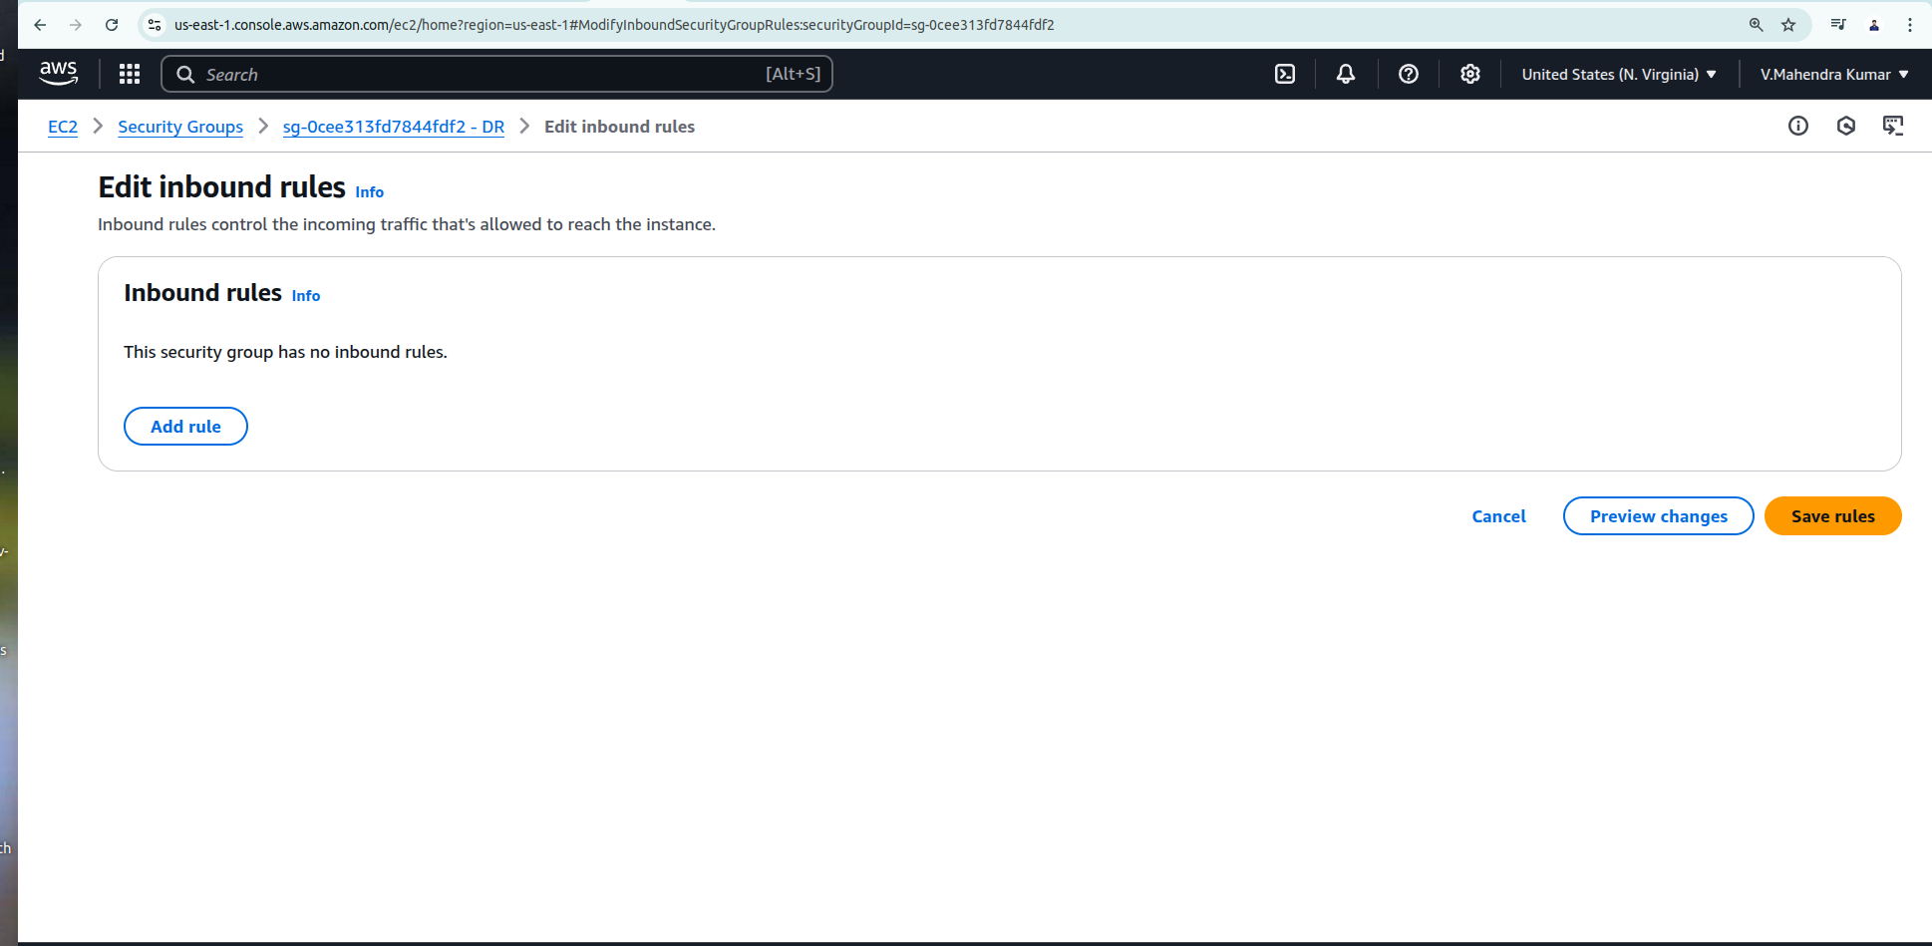attached in DB instance.**

**After make inbound entry we can able to connect Ec2 instance traffic with RDS instance.**

**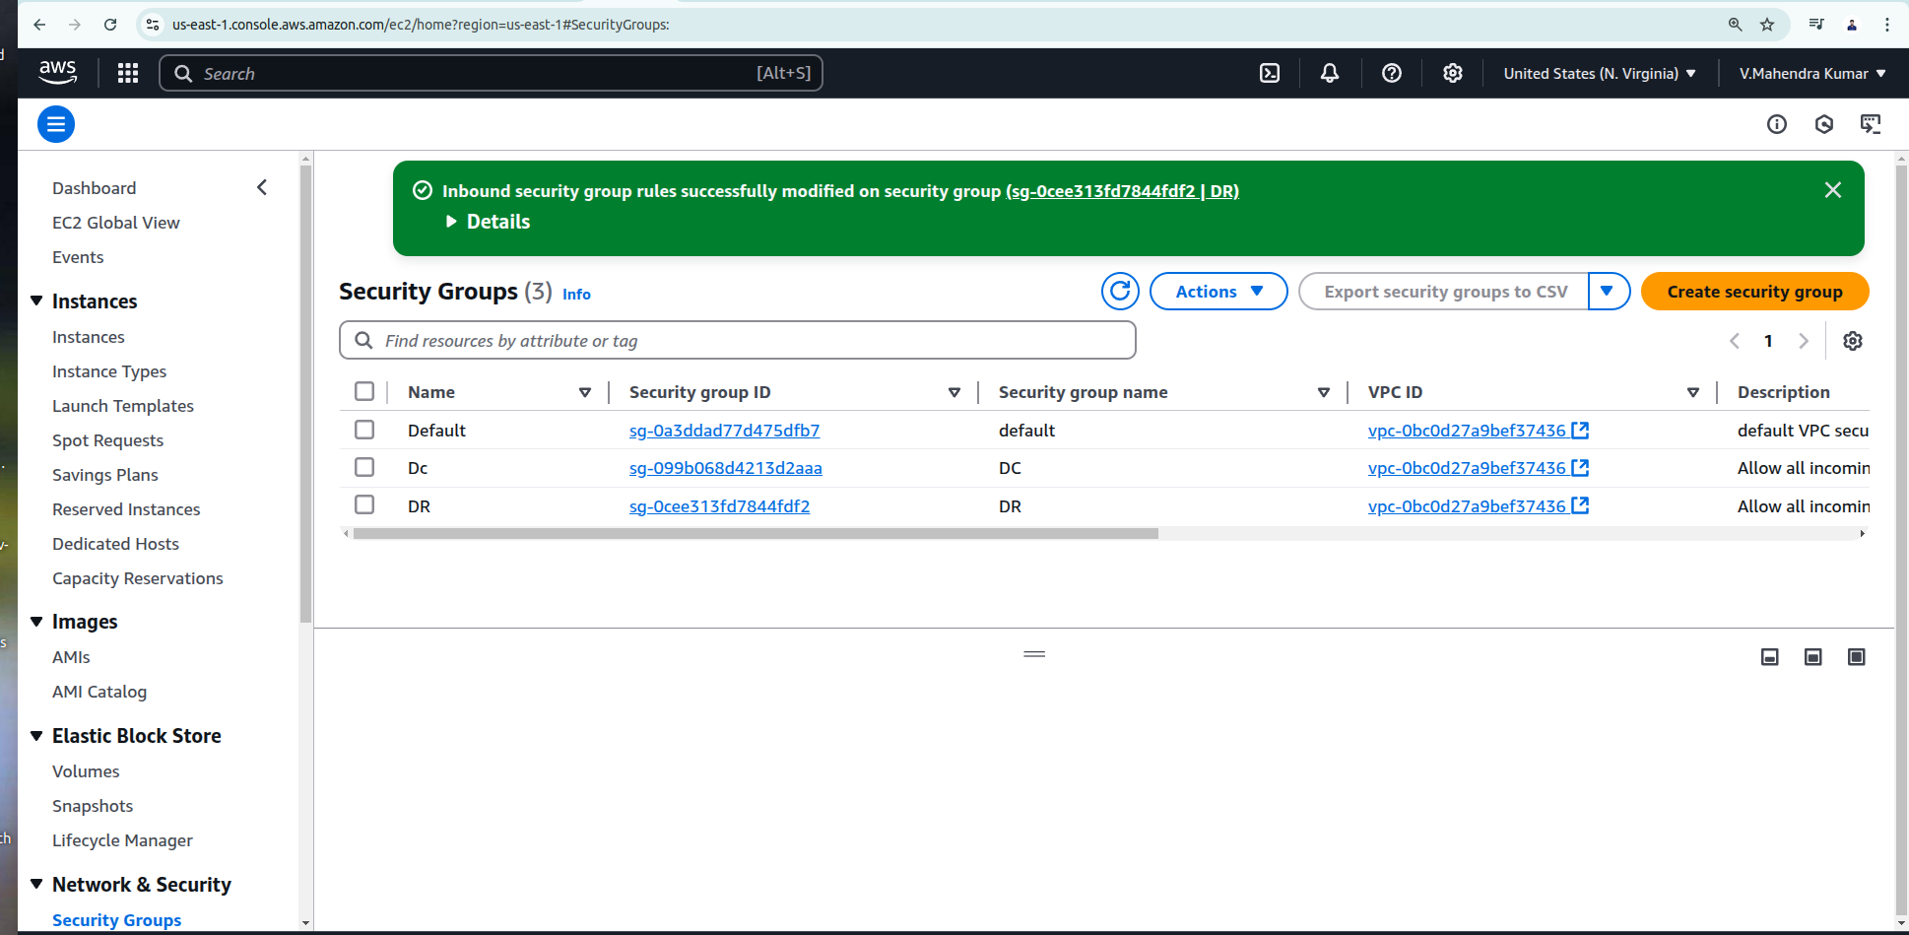  
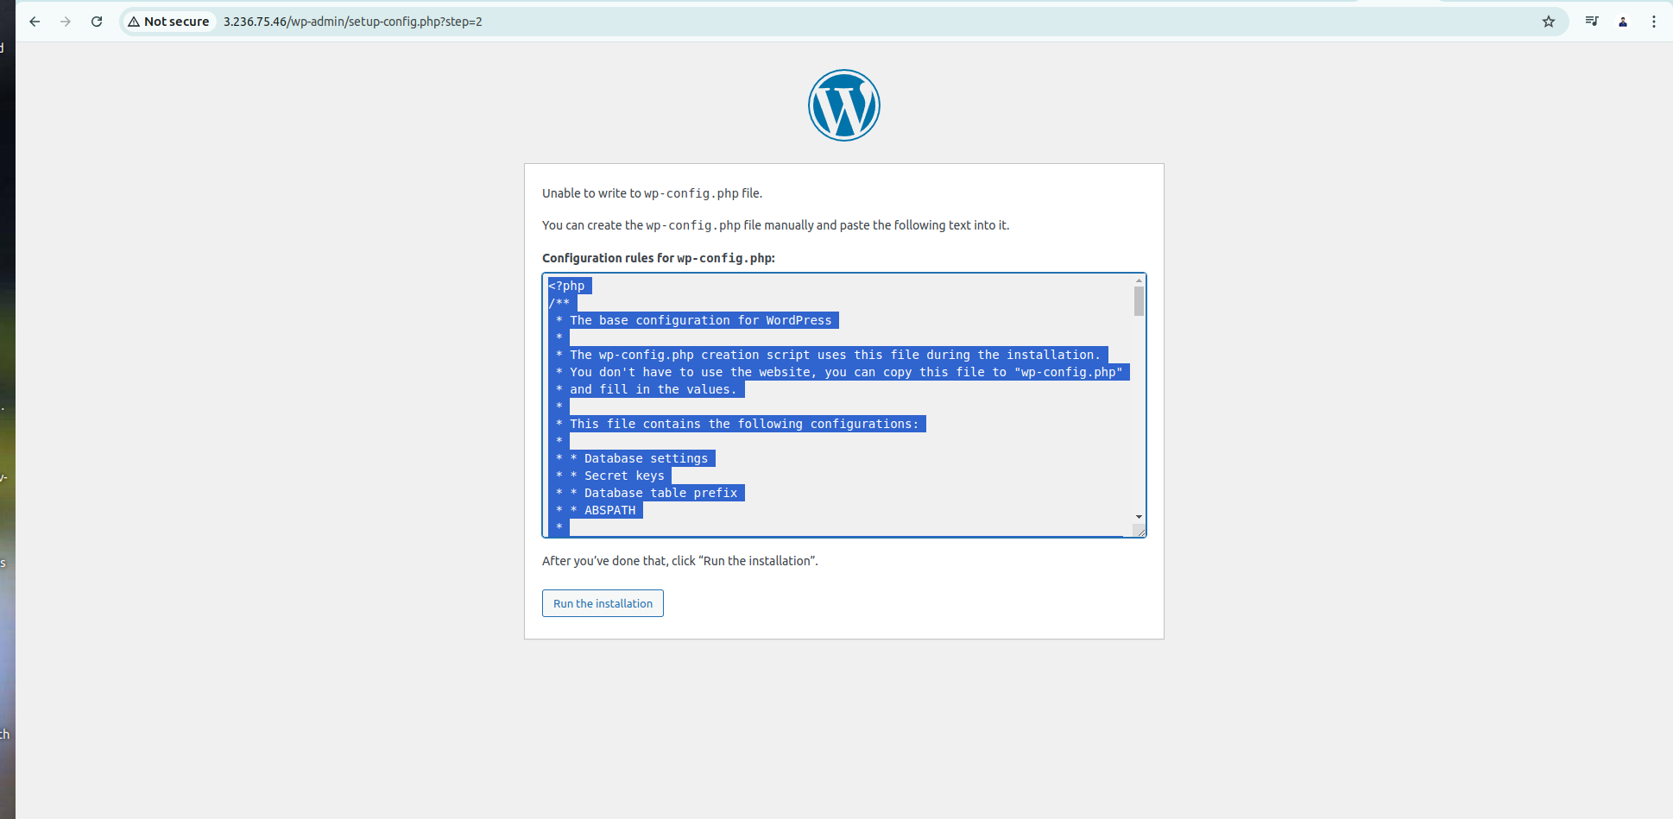**

**Done login both DC and DR server’s for Configuration rules for wp-config.php:  
Instance 1: 3.238.138.135**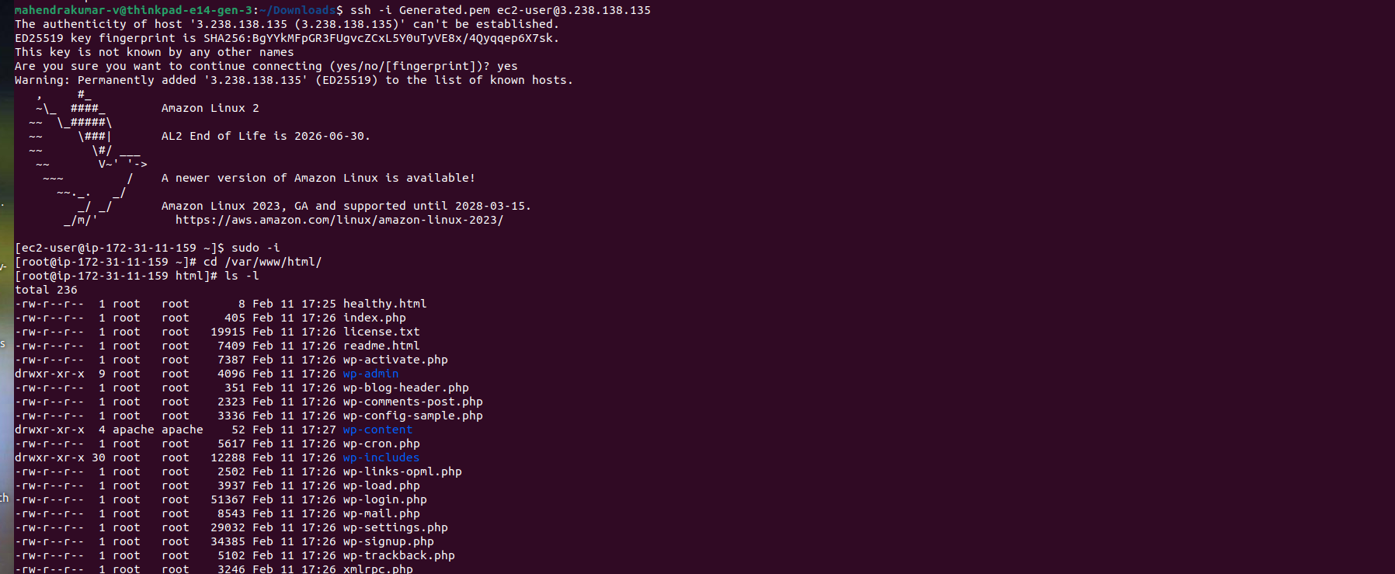

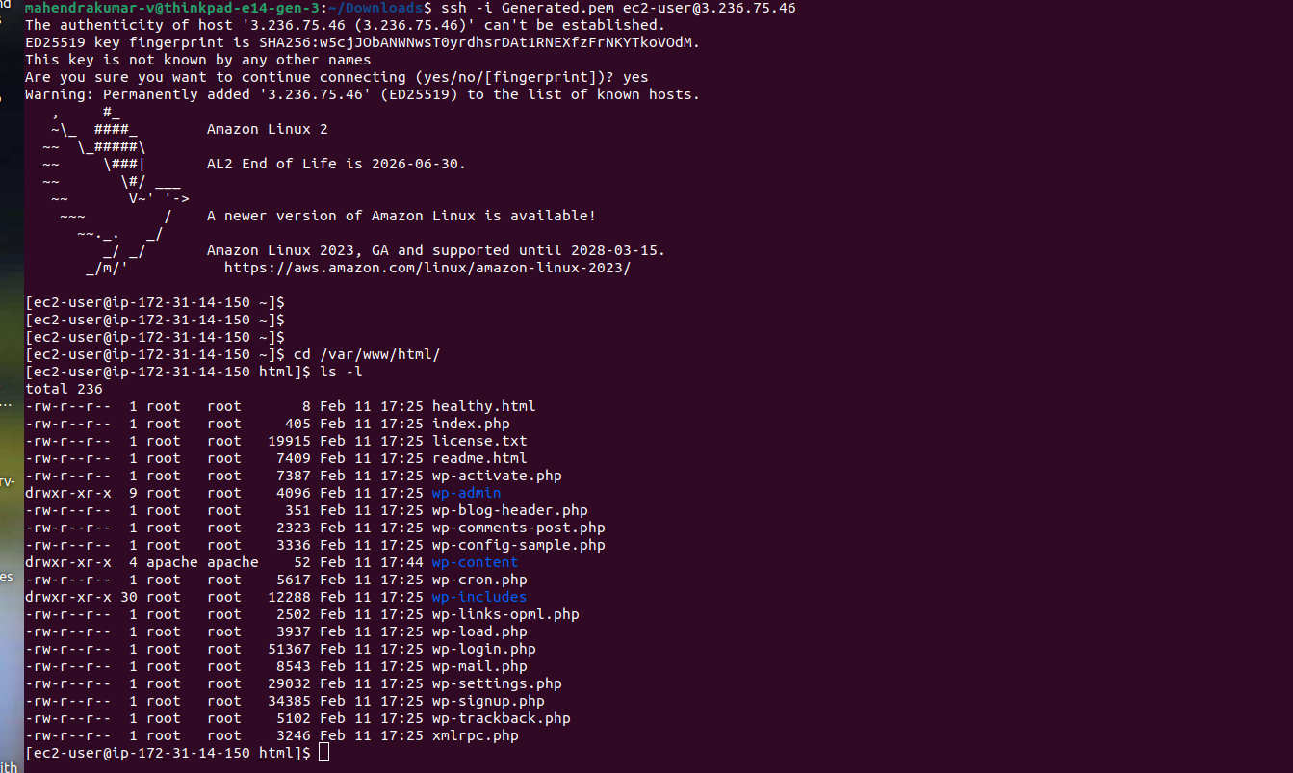**Instance 2: 3.236.75.46**

**After connection establish between Ec2 and RDS we can able to successfully login wordpress application**

**Instance 1: 3.238.138.135**

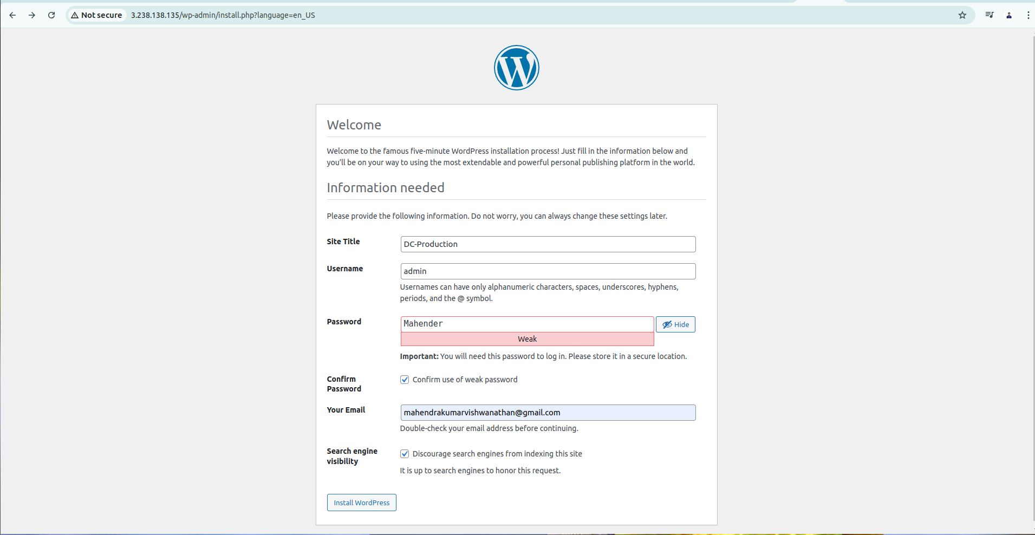

**I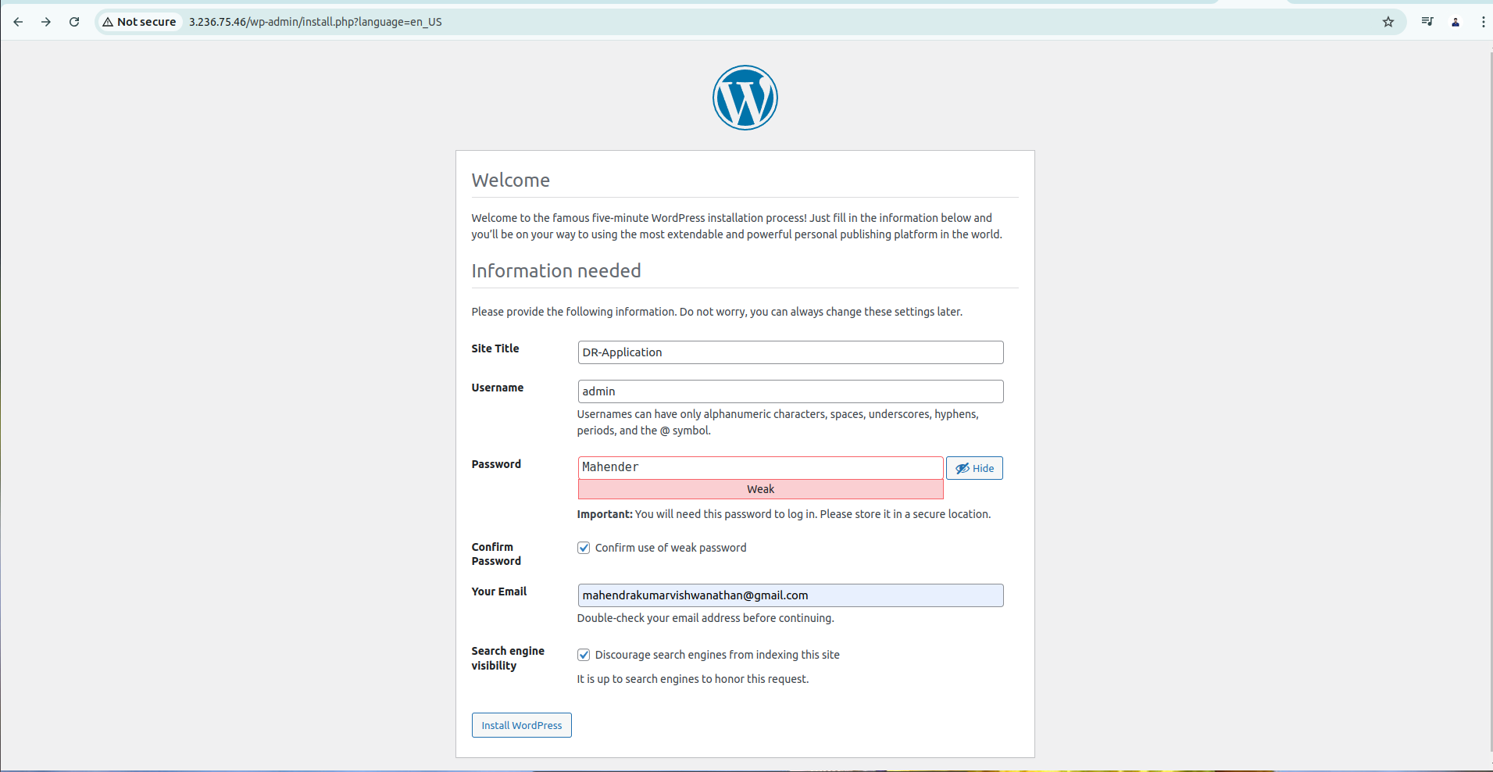nstance 2: 3.236.75.46**

**Instance 1: 3.238.138.135**

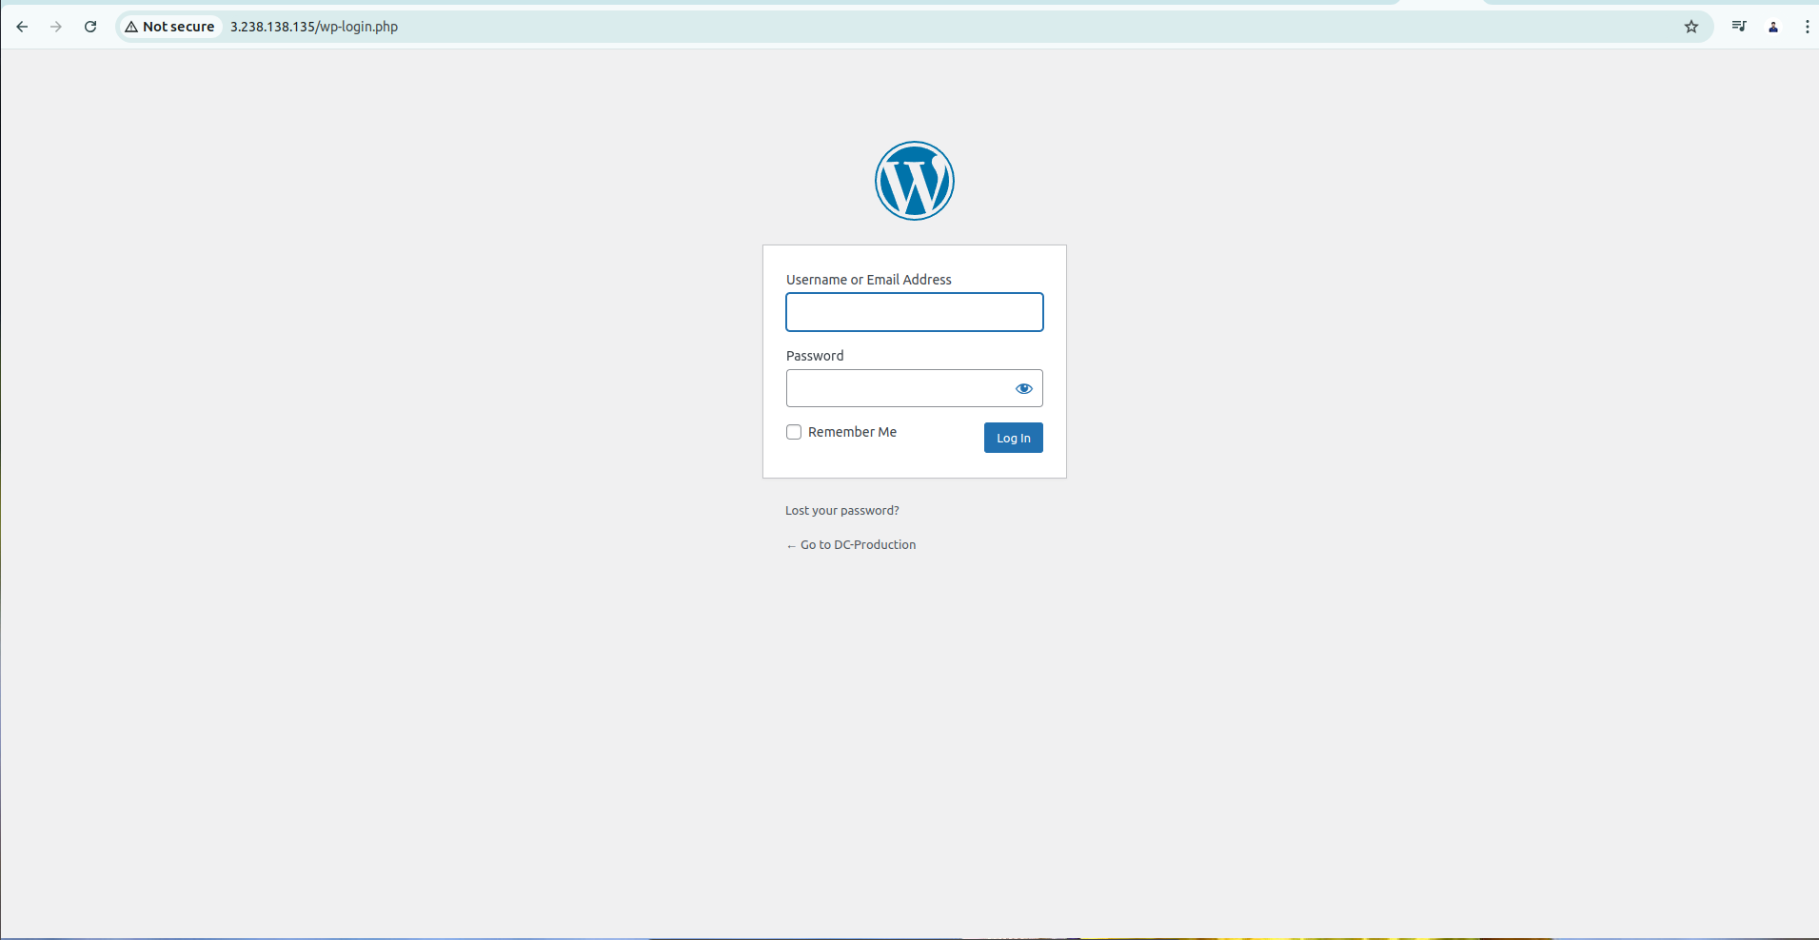

**Instance 2: 3.236.75.46**

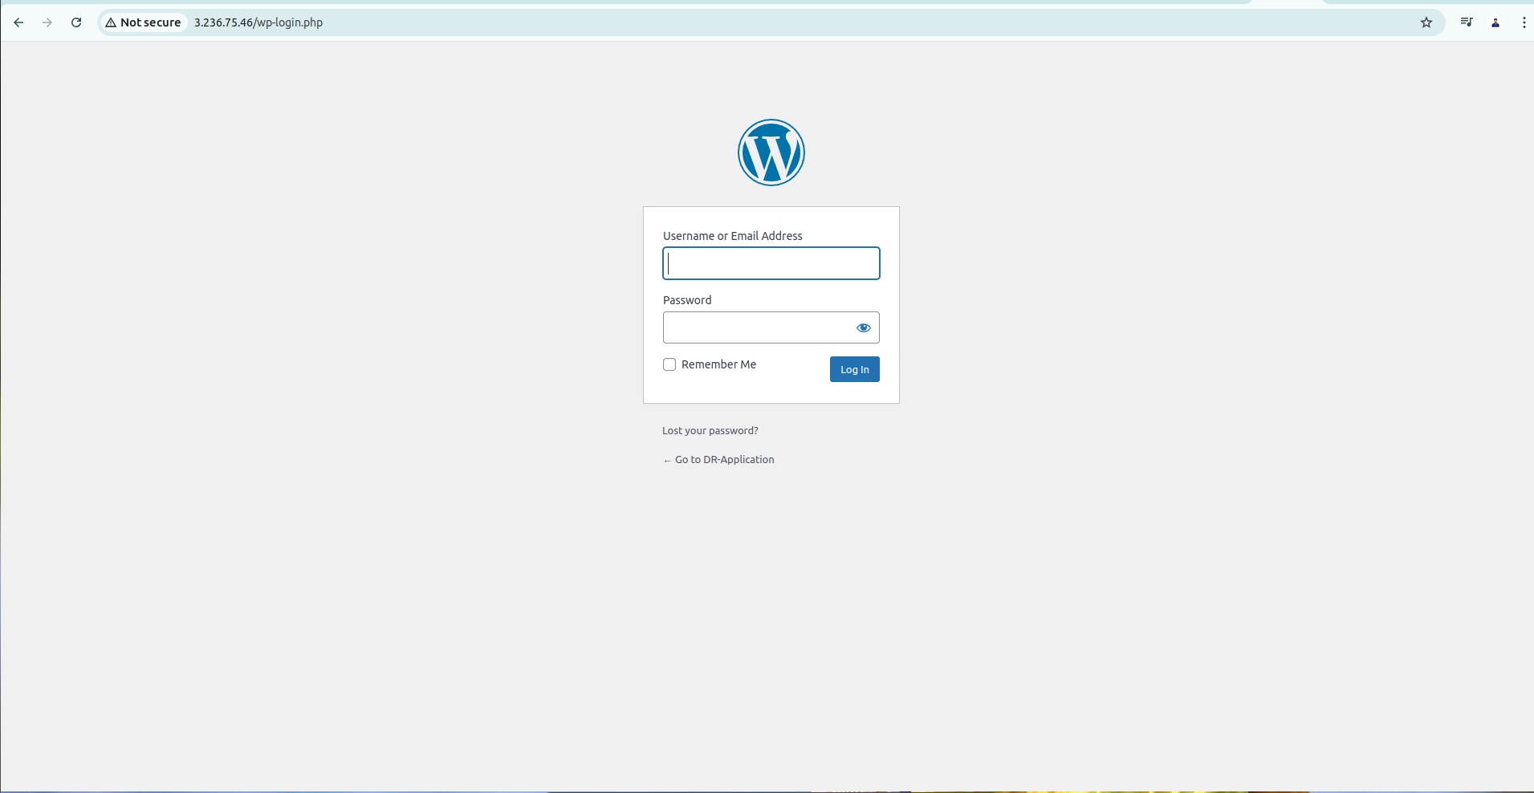

**Instance 1: 3.238.138.135 : Home page of Wordpress from Production Server**

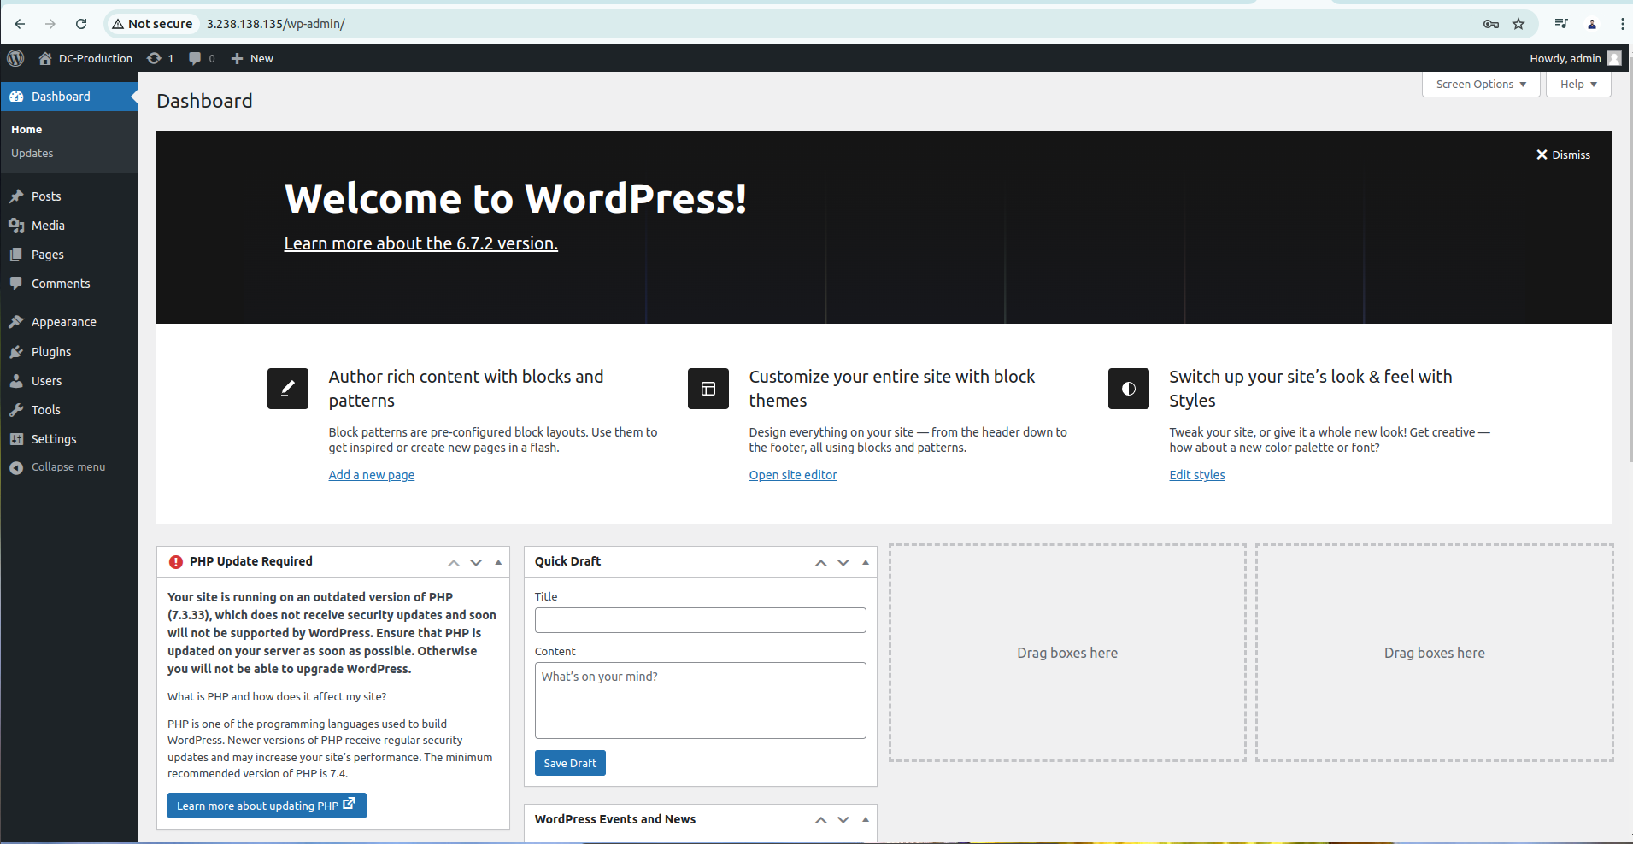

**I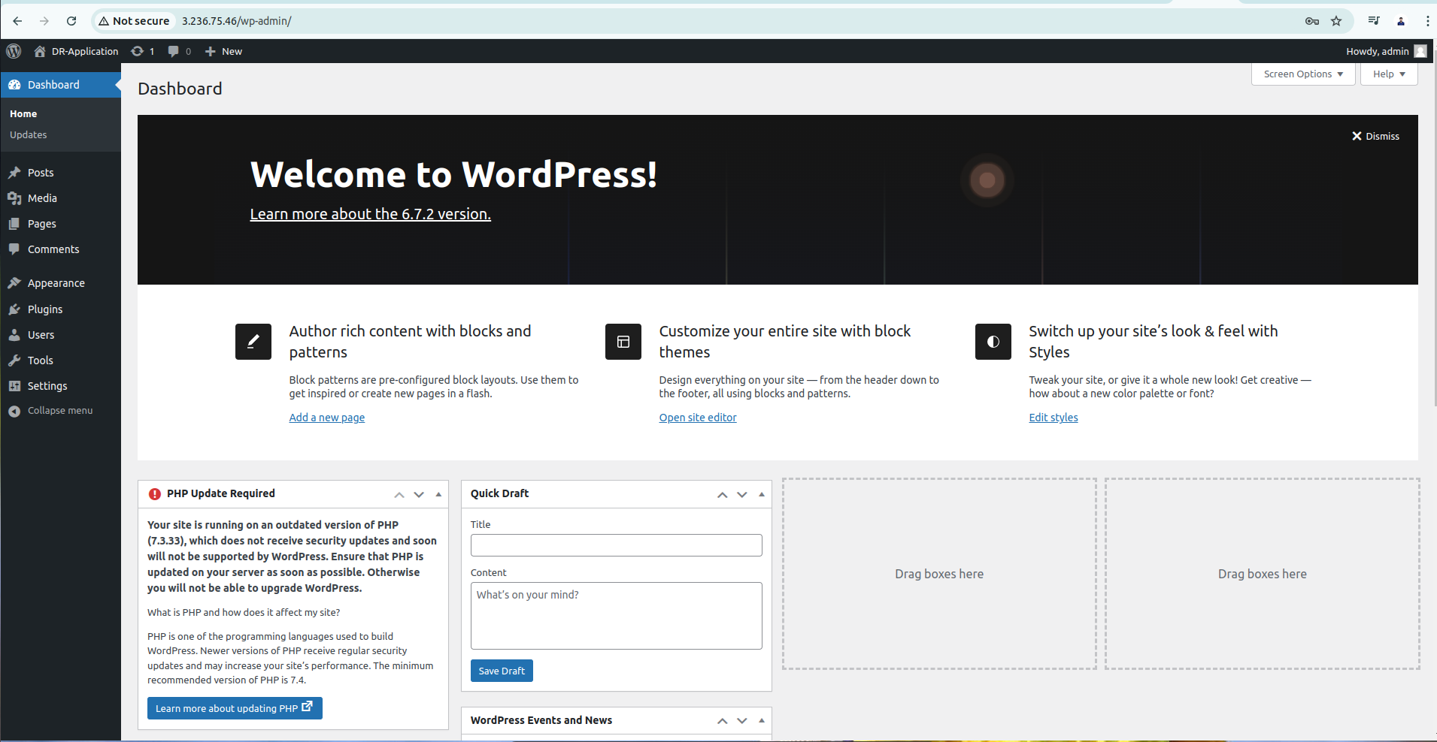nstance 2: 3.236.75.46 Home page of Wordpress from DR Server**

**Instance 1: 3.238.138.135 New from Wordpress in Production Server**

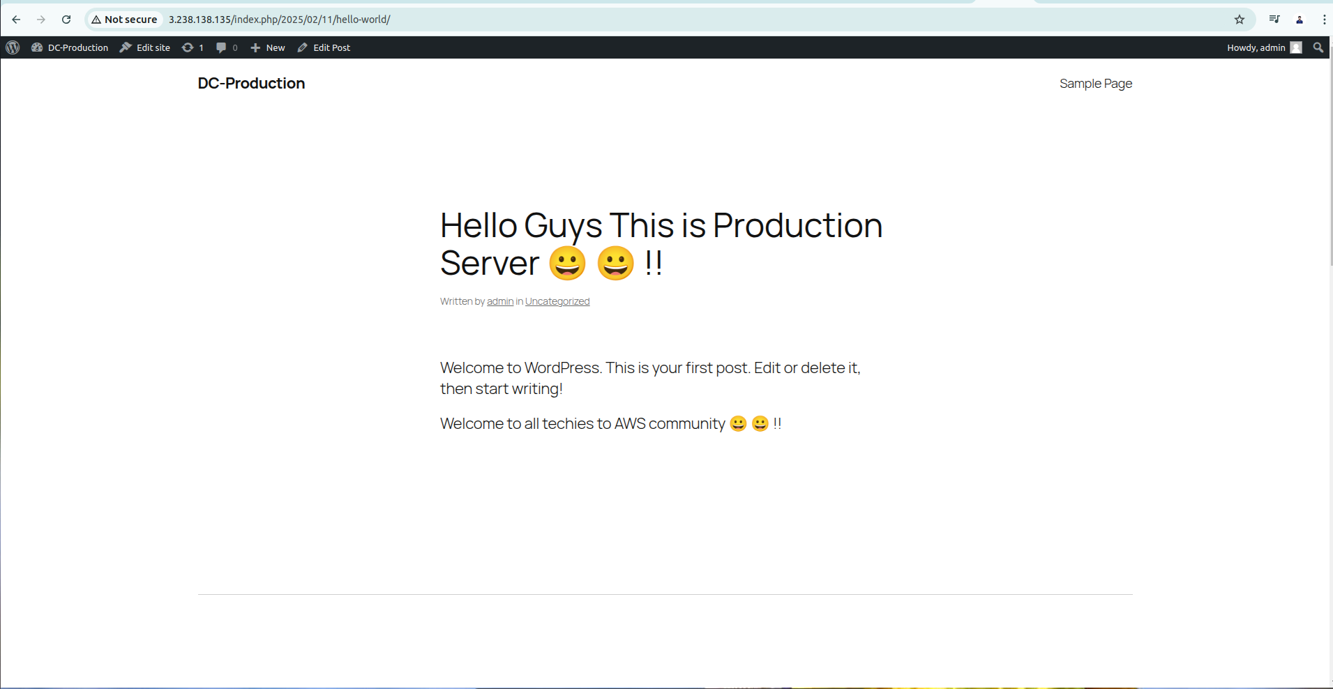

**Instance 2: 3.236.75.46 New from Wordpress in DR Server**

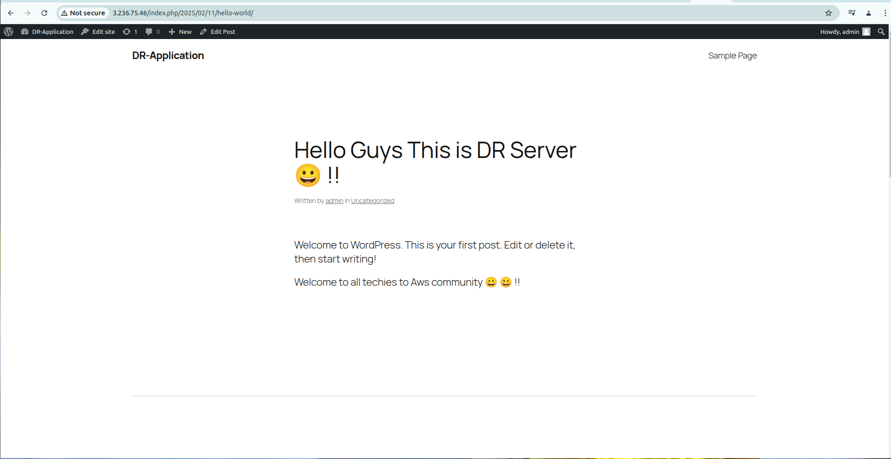

**Now we need to create clasic load balancer,**

**Dc-Load Balancer**

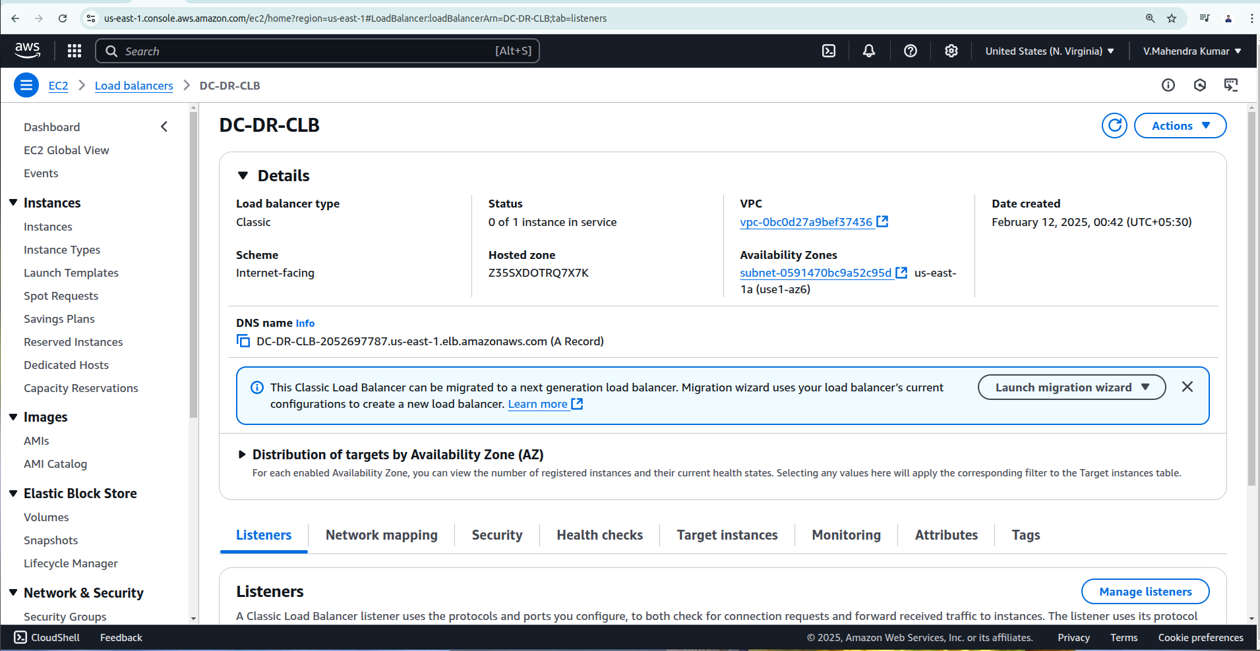

**DR- Load Balancer**

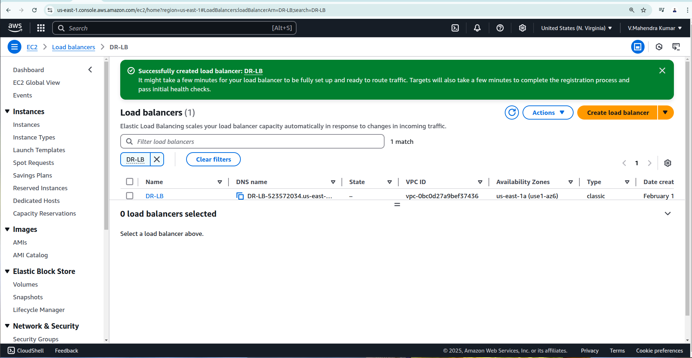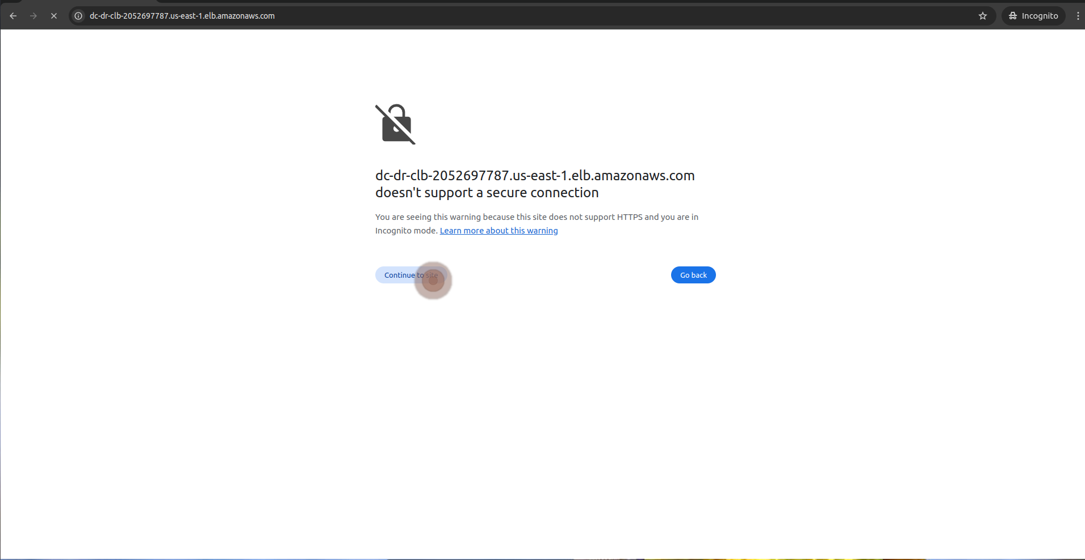

**Guys i got unused status for my targets due to this i could not reach application.**

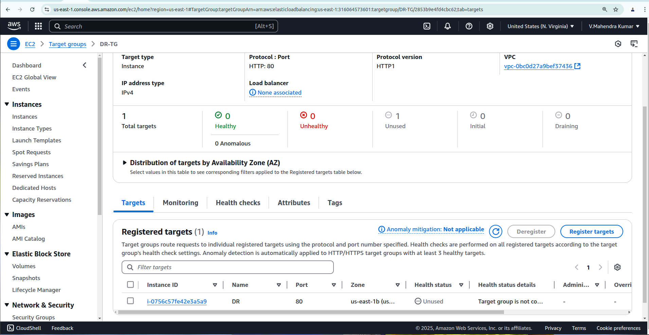

**I Founded issues that i have launched my ec2 instance in us-east-1b, But here my load balancer target group created in us-east-1a, Oppsssssss**

**After chaged Zone now successfully reach application**

**DR-LB: DR-LB-523572034.us-east-1.elb.amazonaws.com  
  
DC-DR-CLB : DC-DR-CLB-2052697787.us-east-1.elb.amazonaws.com**

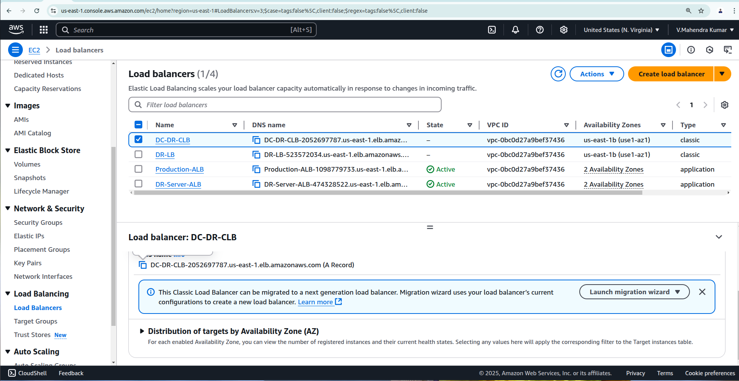

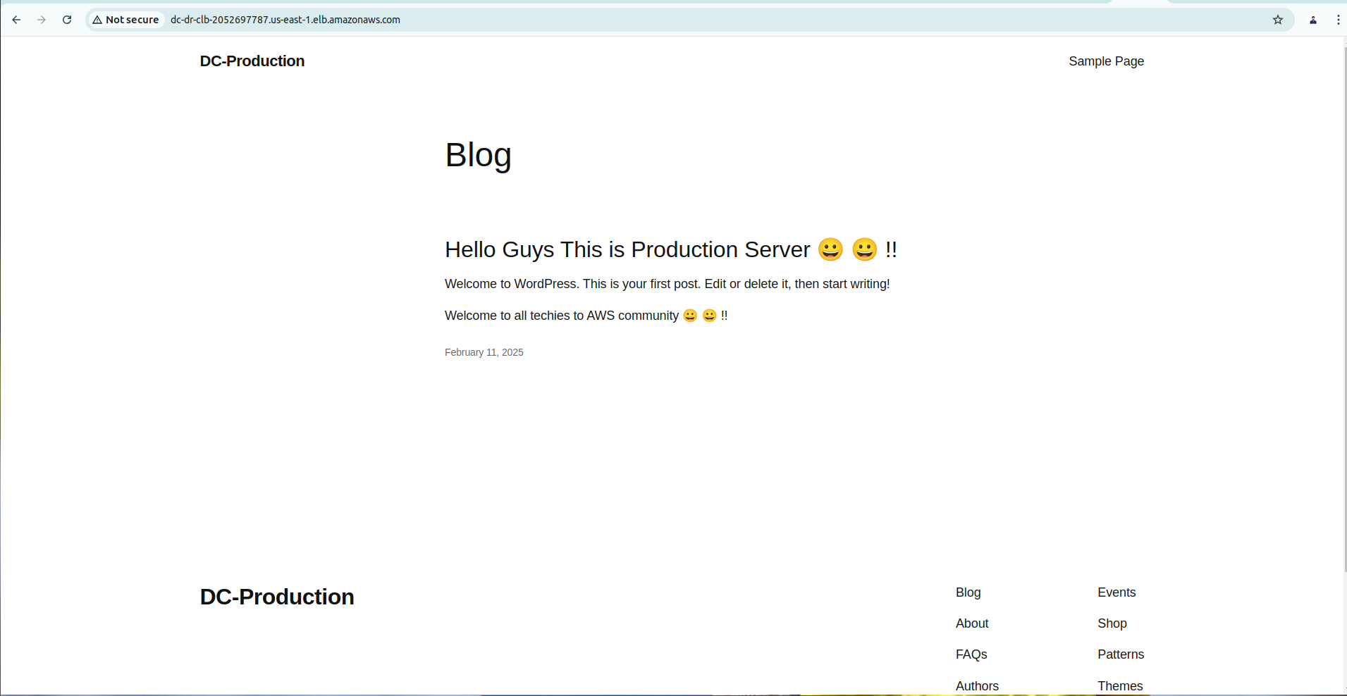

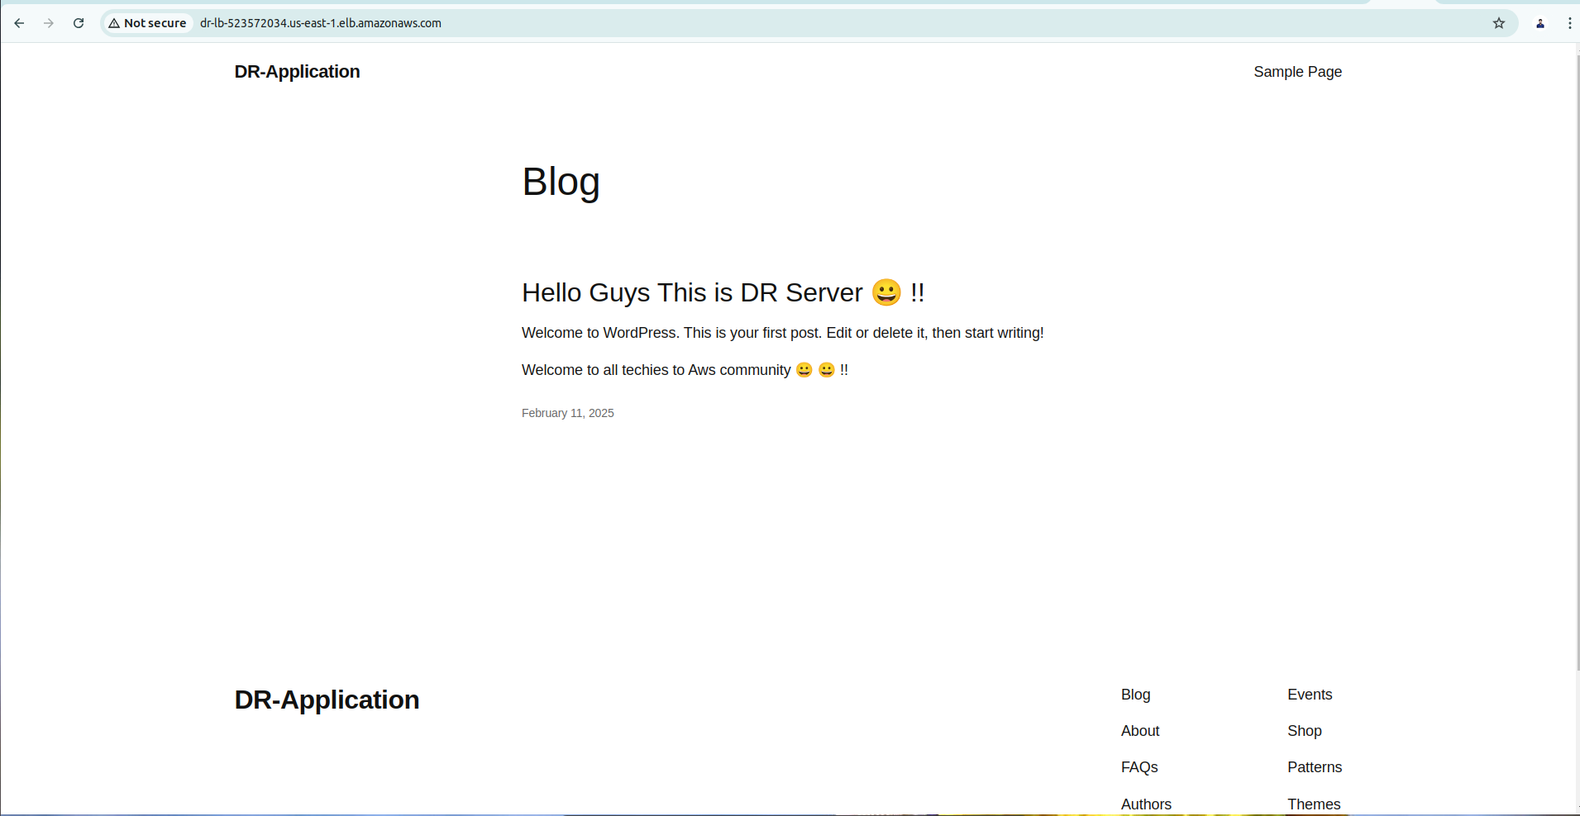

**Now create a record set from route 53 and route traffic from classic load balancer in to route 53 (Domain) route 53 route application traffic as per the routing policy.**

W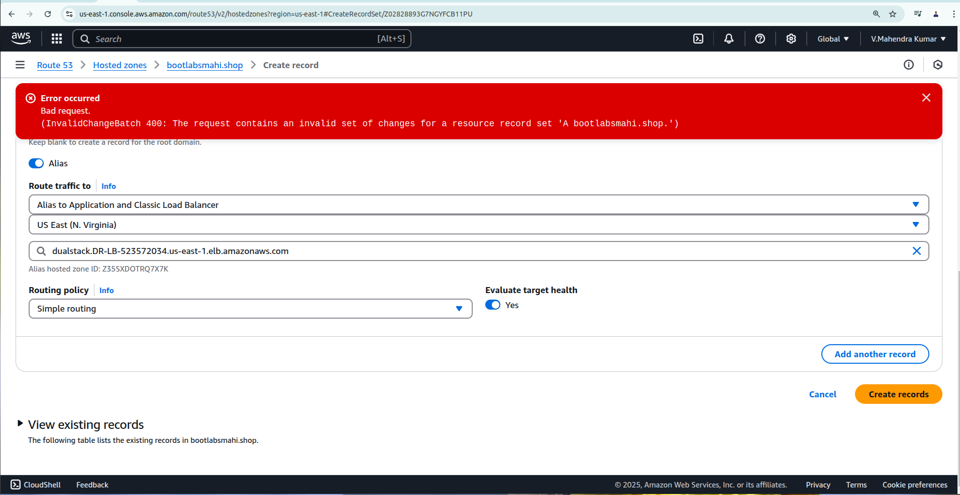e have issues while create A records with simple routing policy.

**Issue is when we create one more record for DR we should mention the record name as DR or something else  
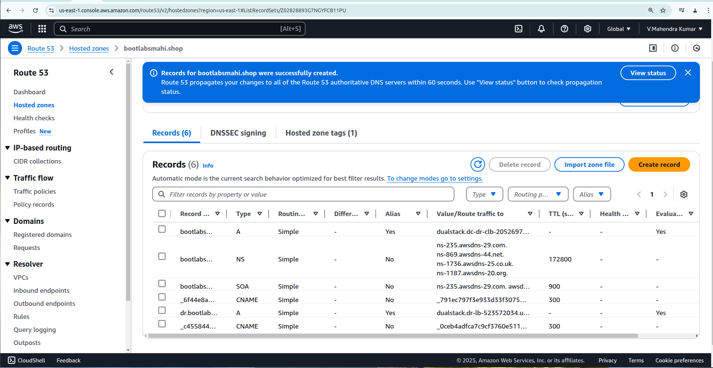**

**Propogation has been done and INSYNC status   
  
  
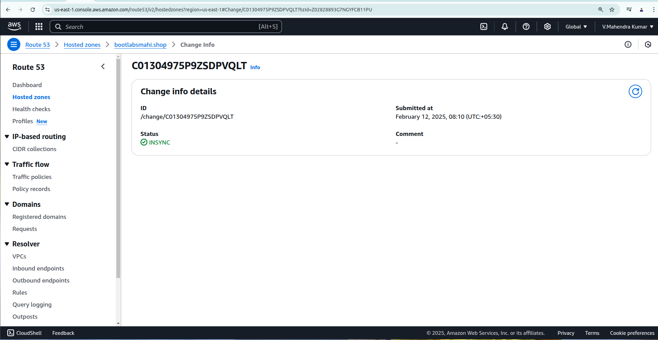Now can see addition 2 more A records .**

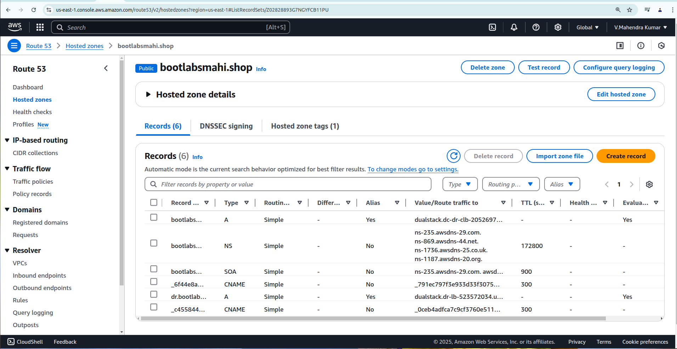

**Here i can able to reach both Production application server as well DR server with my domain name  
  
Prduction : http://bootlabsmahi.shop/  
  
DR :** [**http://dr.bootlabsmahi.shop/**](http://dr.bootlabsmahi.shop/) 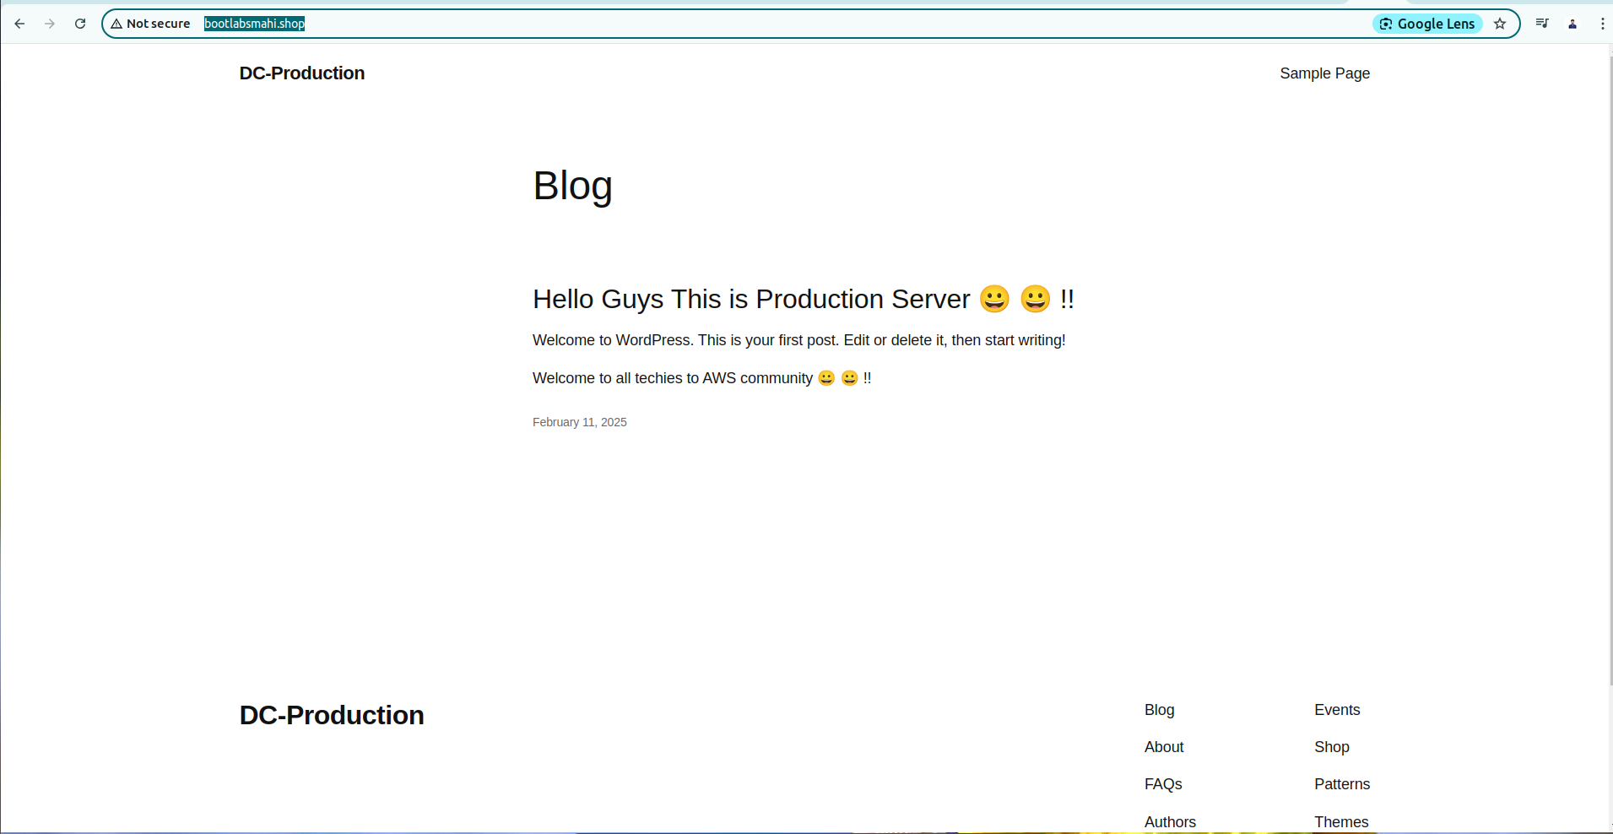

**DR :** [**http://dr.bootlabsmahi.shop/**](http://dr.bootlabsmahi.shop/) 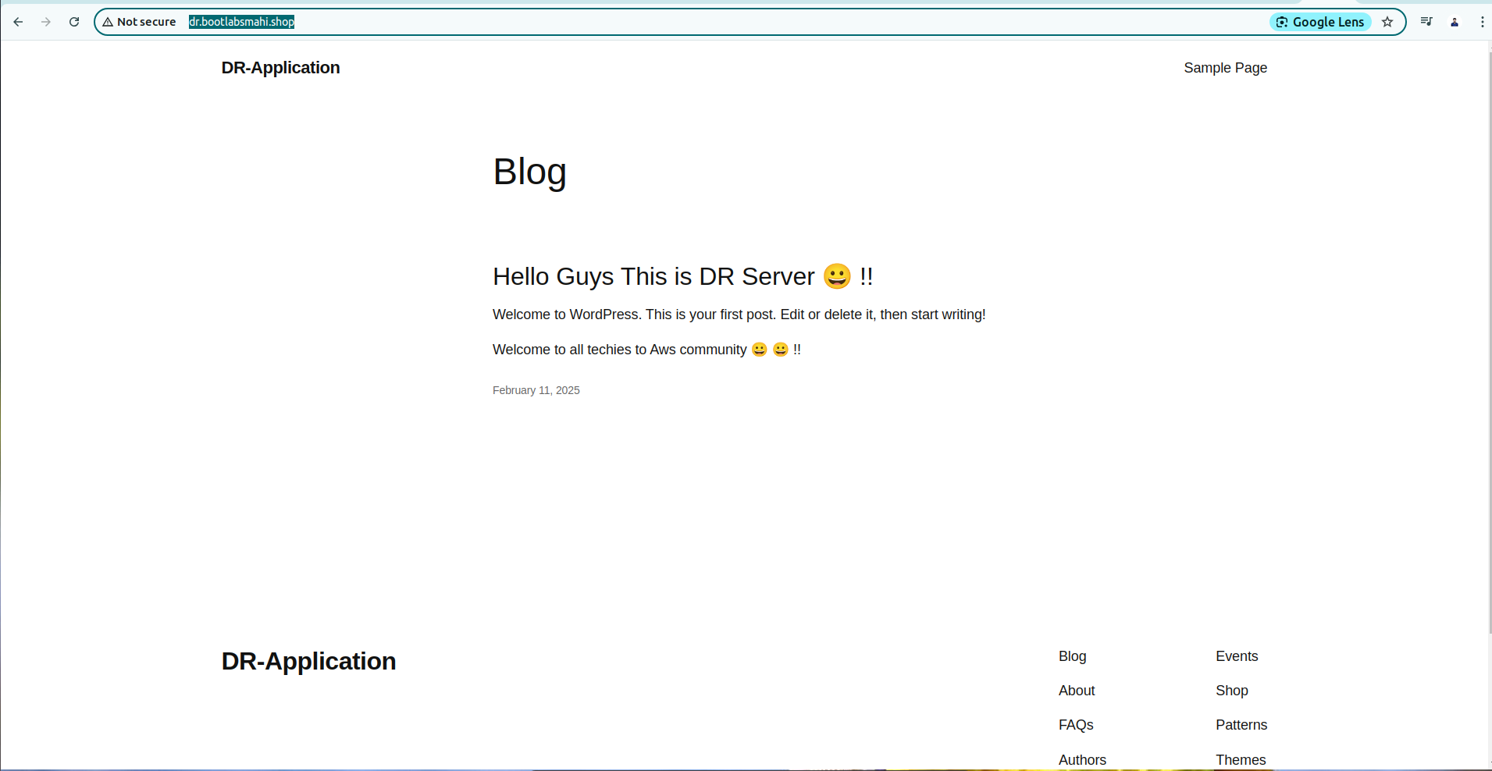

**Now we need to create couple of bucket for make sync between production in to DR.**

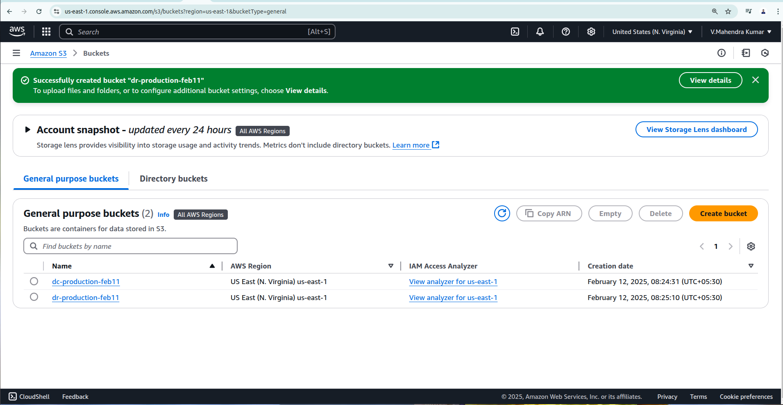

**Now start sync content from Production in to S3, Then start sync content from S3 in to DR  
  
PRODUCTION:**

*/2 * * * * aws s3 sync --delete /var/www/html/wp-content/uploads s3://dc-production-feb11

*/2 * * * * aws s3 sync --delete /var/www/html/ s3://dr-production-feb11

**DR:**

*/2 * * * * aws s3 sync --delete s3://dc-production-feb11 /var/www/html/wp-content/uploads

*/2 * * * * aws s3 sync --delete s3://dr-production-feb11/var/www/html/

**We can connect both production and DR instance and list bucket.  
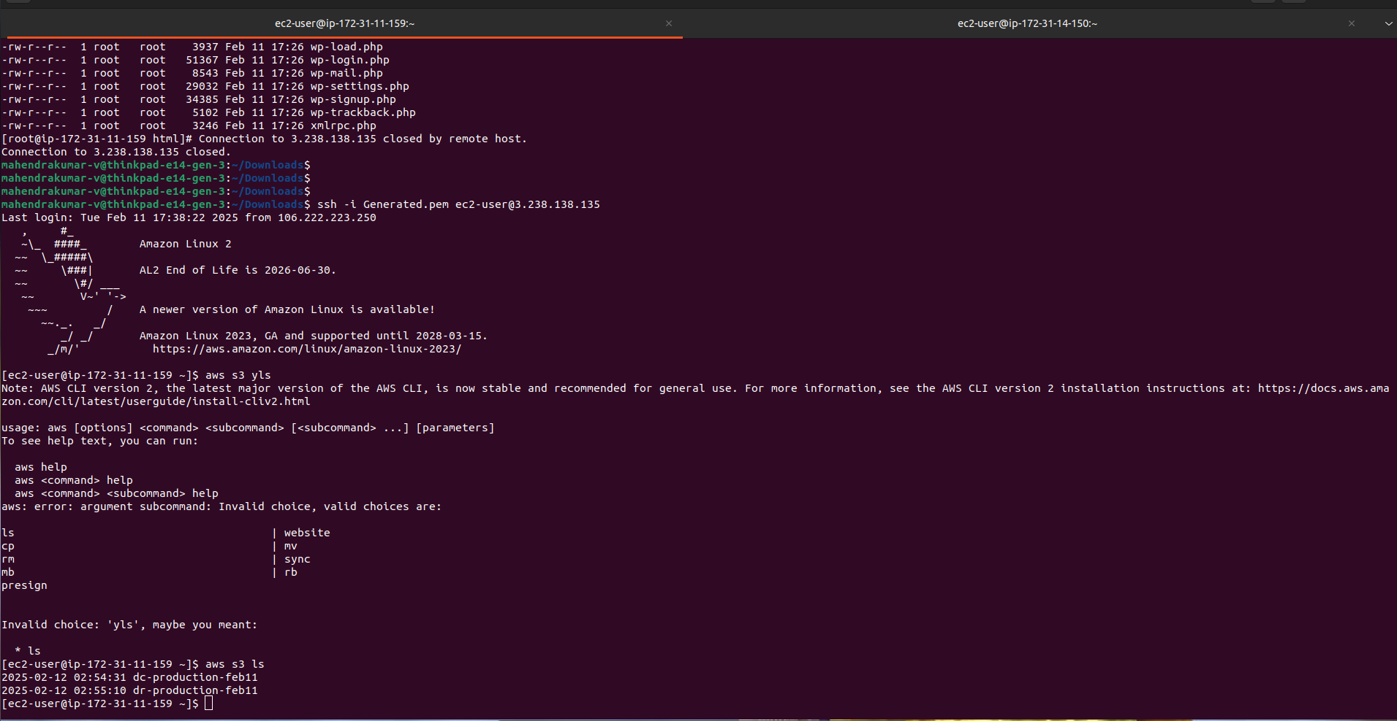**

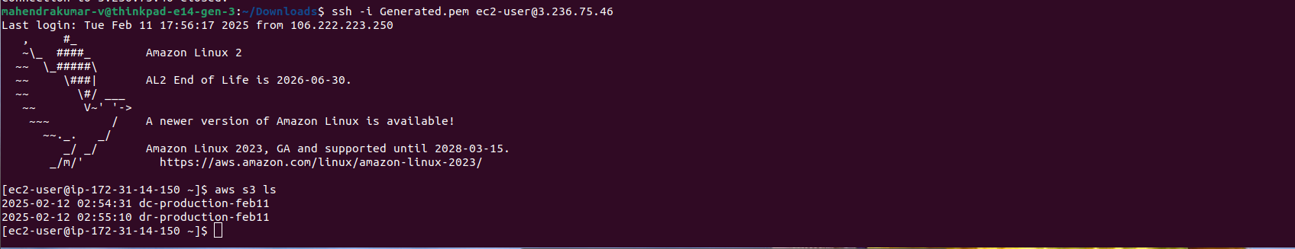

*/2 * * * * aws s3 sync --delete /var/www/html/wp-content/uploads s3://dc-production-feb11

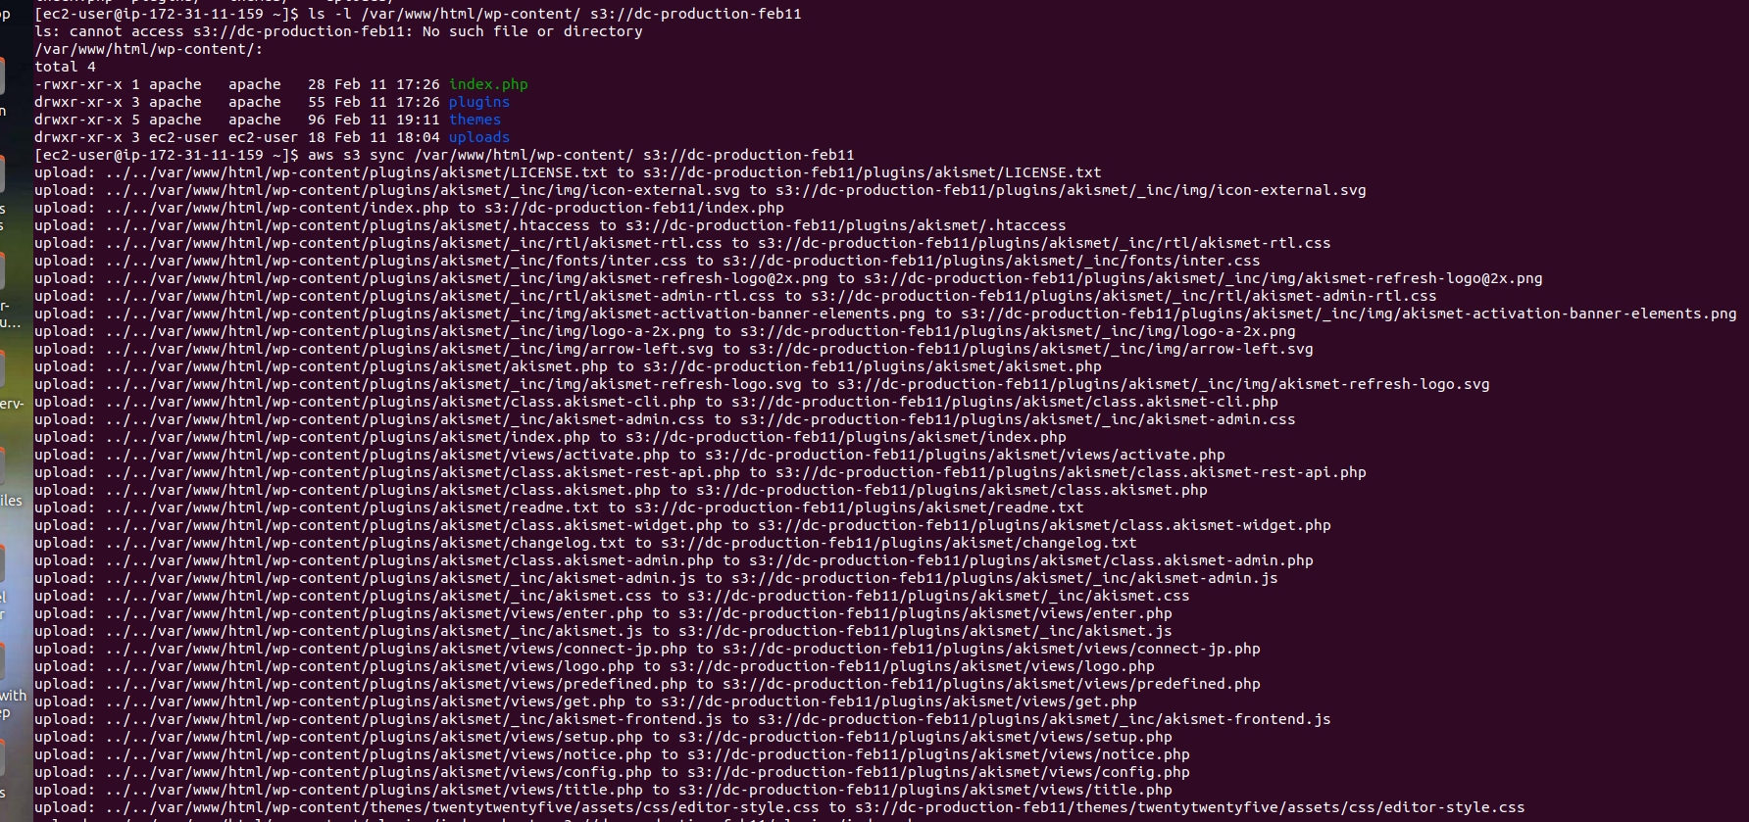

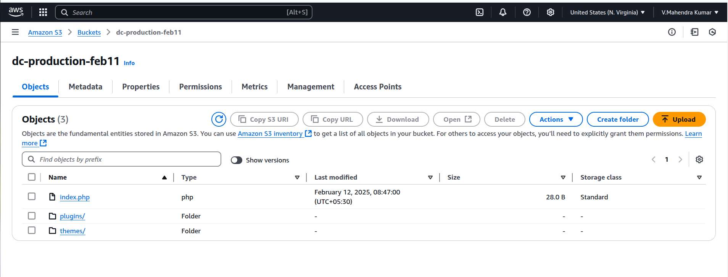

*/2 * * * * aws s3 sync --delete /var/www/html/ s3://dr-production-feb11 **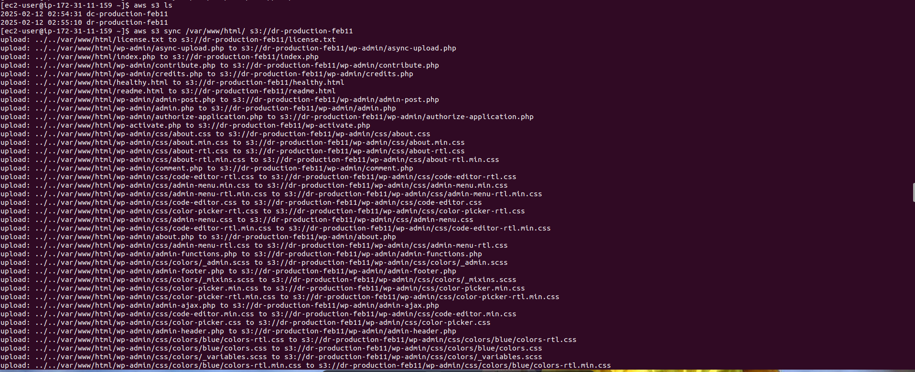  
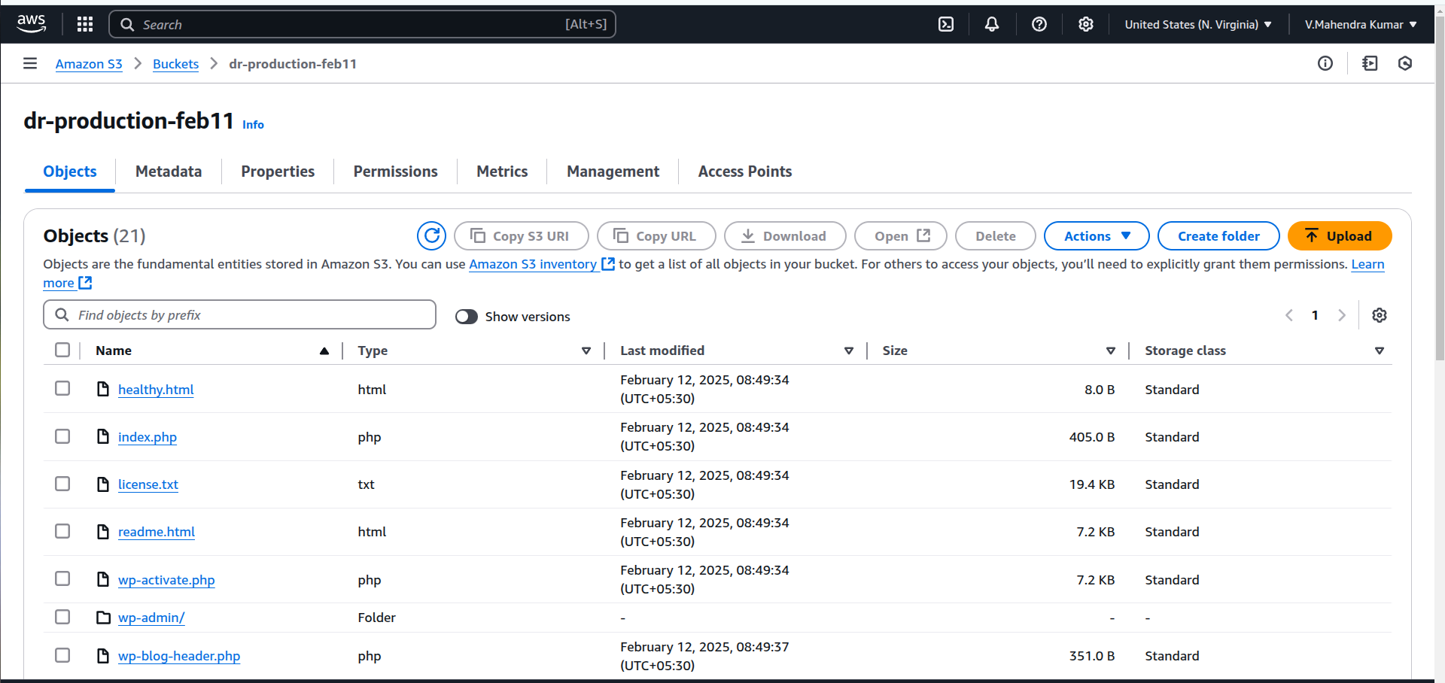**

**Production Server (DC) :**

*/2 * * * * aws s3 sync --delete /var/www/html/wp-content/uploads s3://dc-production-feb11

*/2 * * * * aws s3 sync --delete /var/www/html/ s3://dr-production-feb11

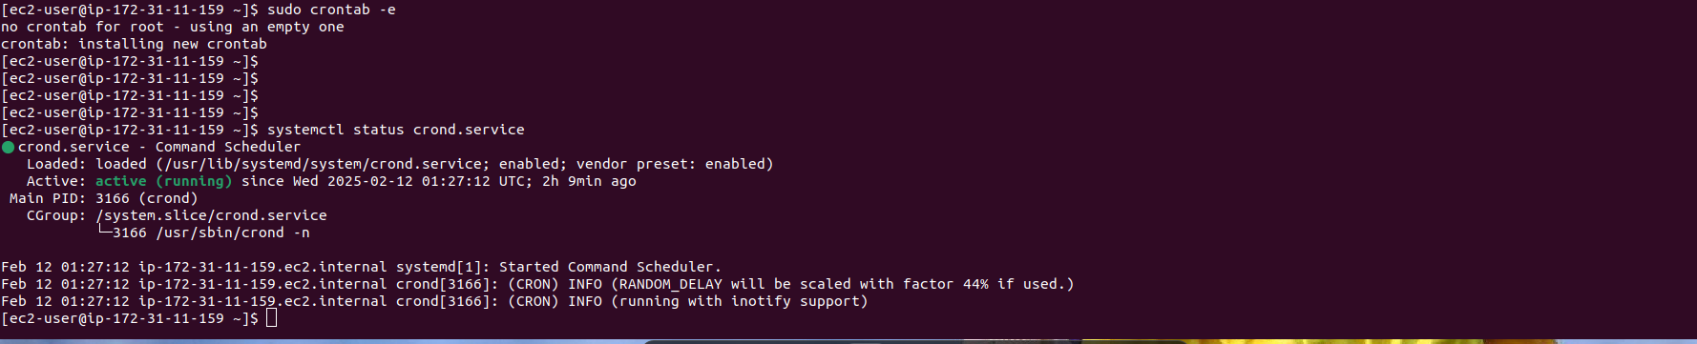

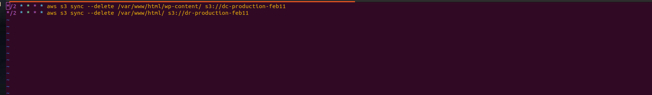

**DR:**

*/2 * * * * aws s3 sync --delete s3://dc-production-feb11 /var/www/html/wp-content/uploads

*/2 * * * * aws s3 sync --delete s3://dr-production-feb11 /var/www/html/

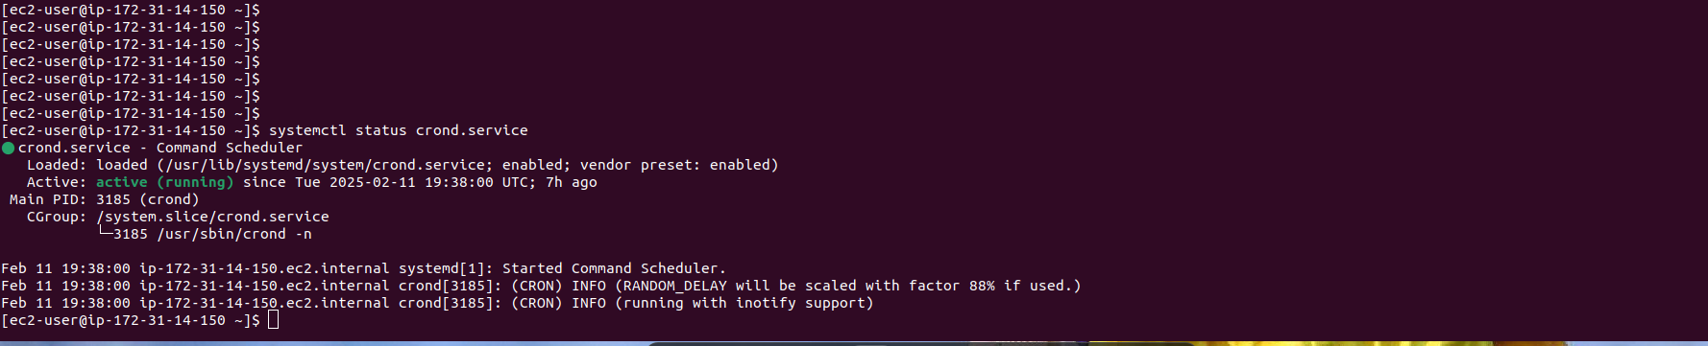

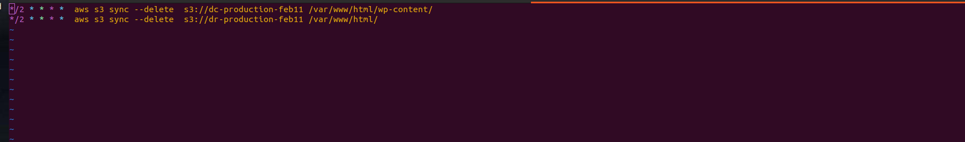

**After successfully set and cron has been started every 2 min and synced data from production in to DR.**

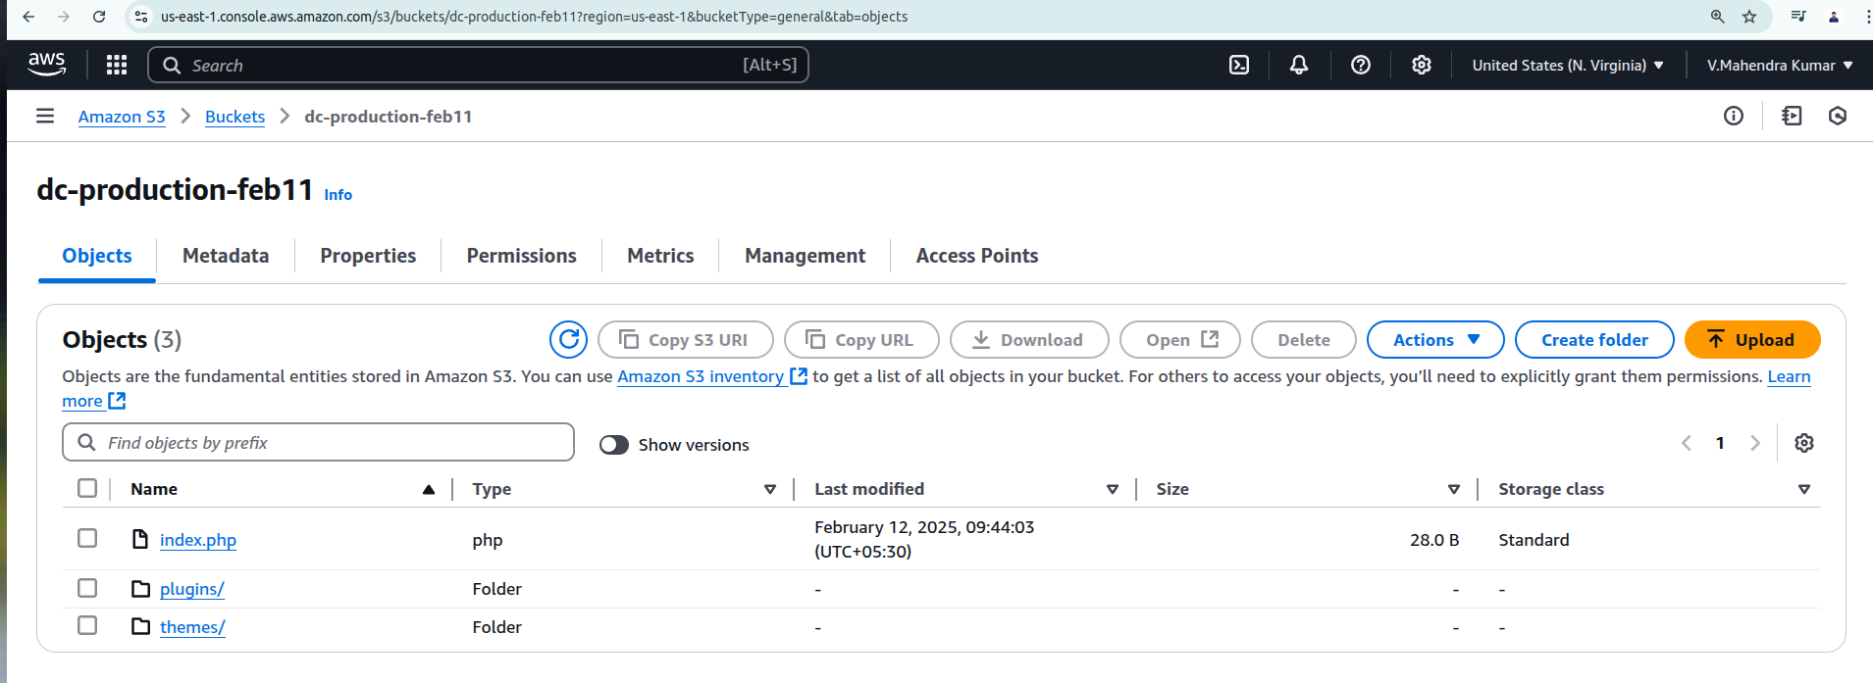

**After sync content from the production in to DR server, Now both server have the same content distruibuted.**

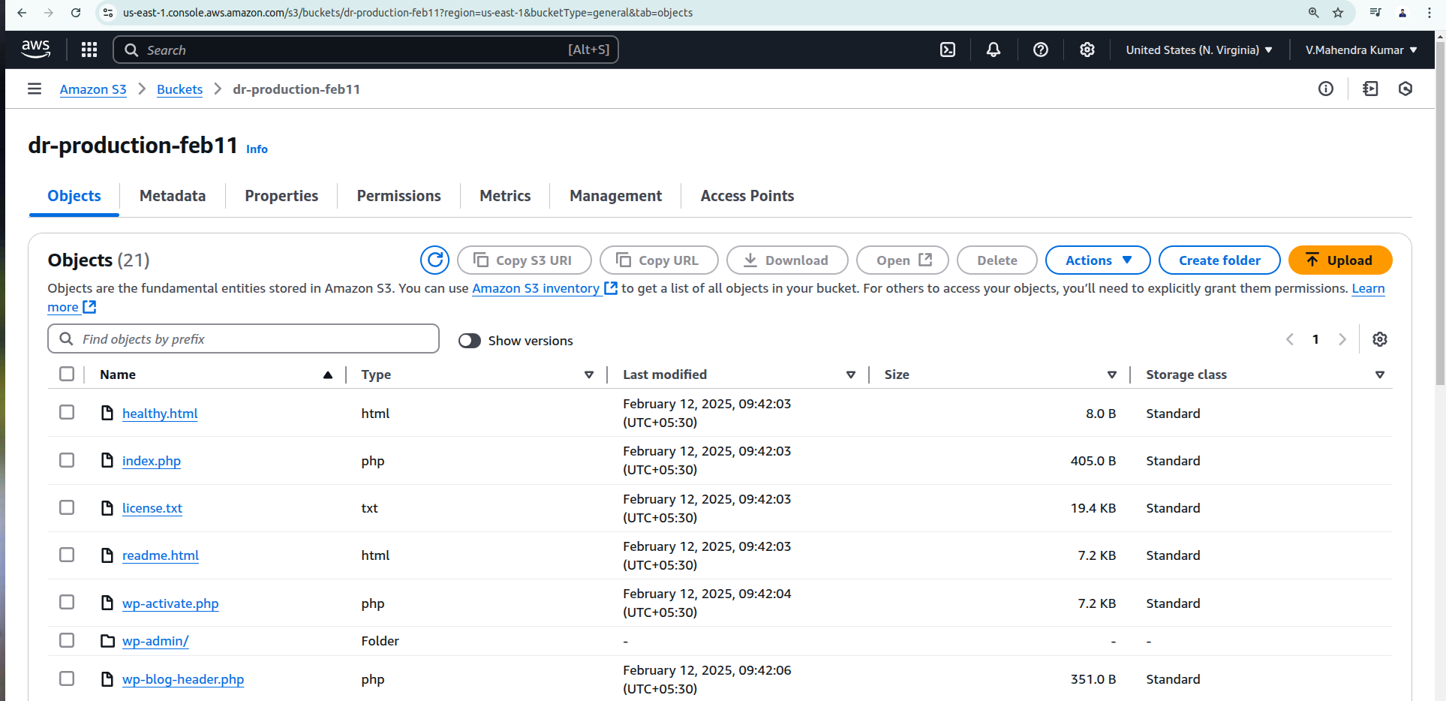

**Production :** [**http://bootlabsmahi.shop/**](http://bootlabsmahi.shop/)

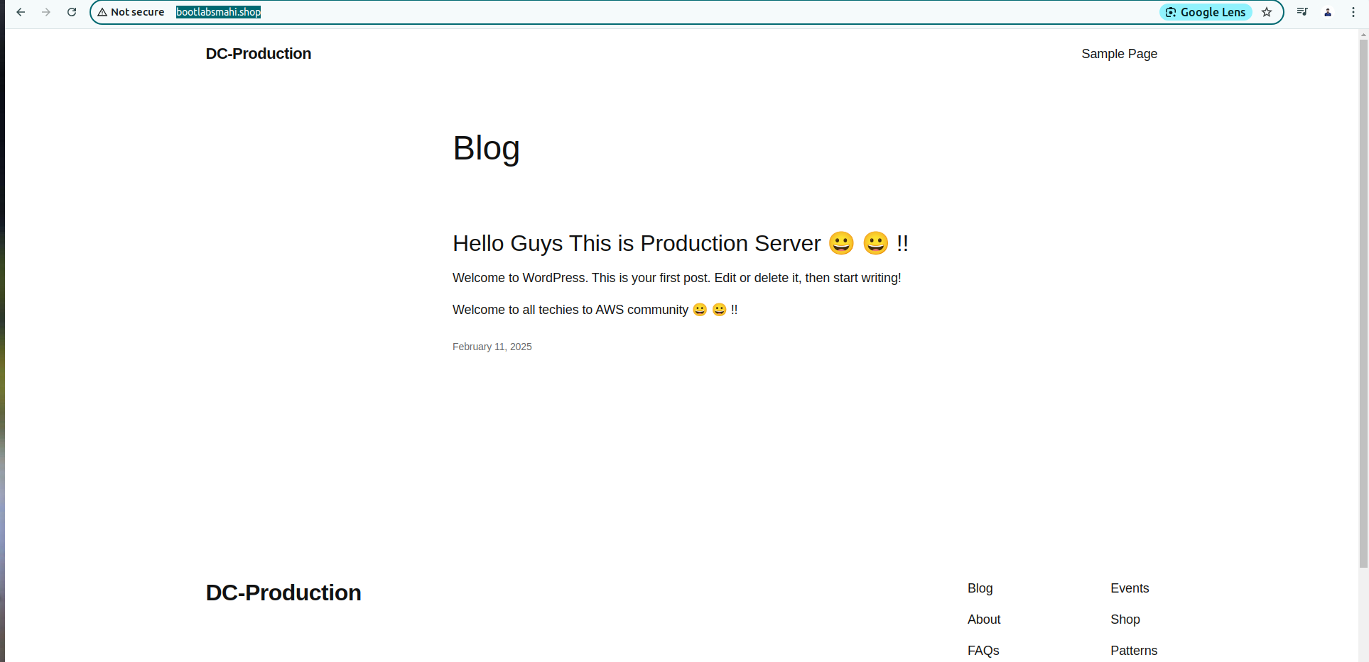

**DR:** [**http://dr.bootlabsmahi.shop/**](http://dr.bootlabsmahi.shop/)

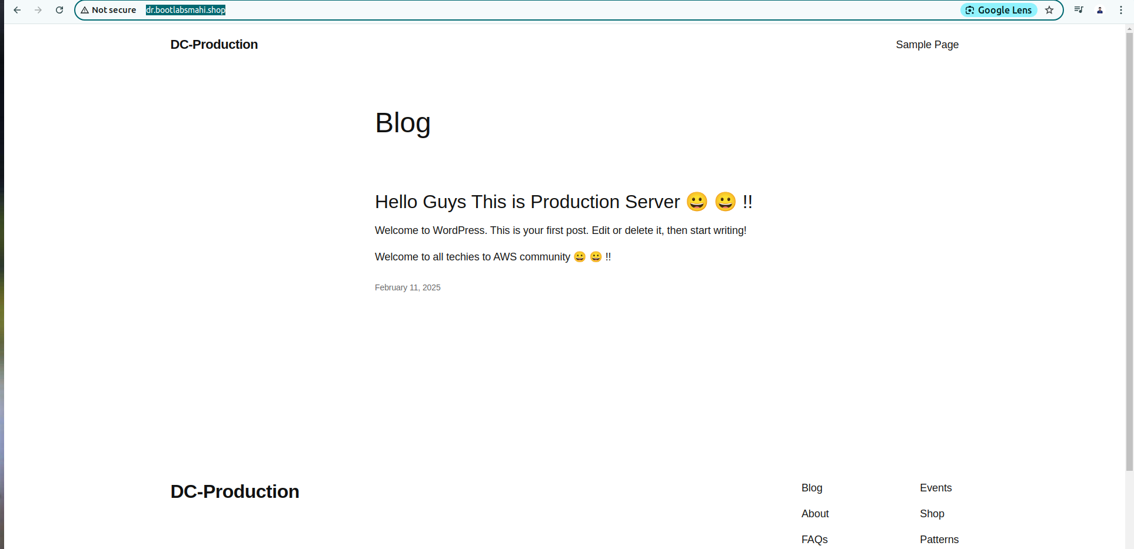

**Here if once production goes down content serve from the DR server. Because of S3 buckey sync every 2 min from prod to DR.**

**Now i want to serve my content in secure way (from http to https)**

**Certificate issues by ACM:**

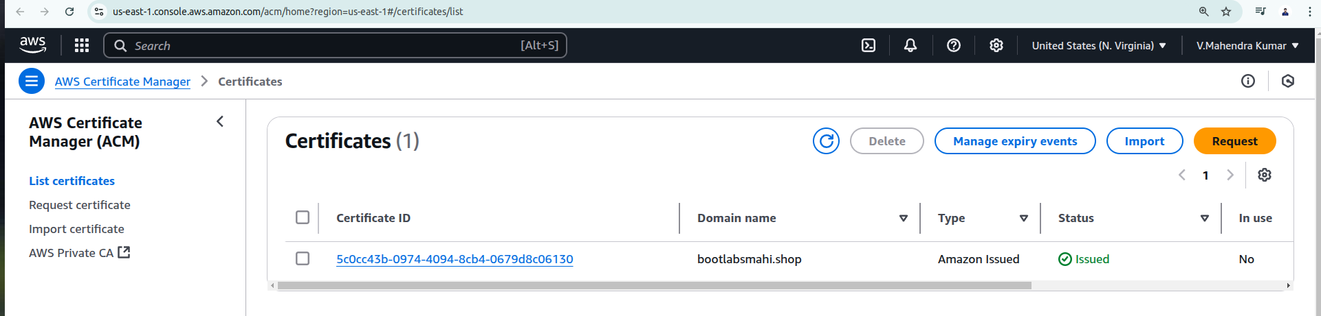

**Configure listerner from http in to https:**

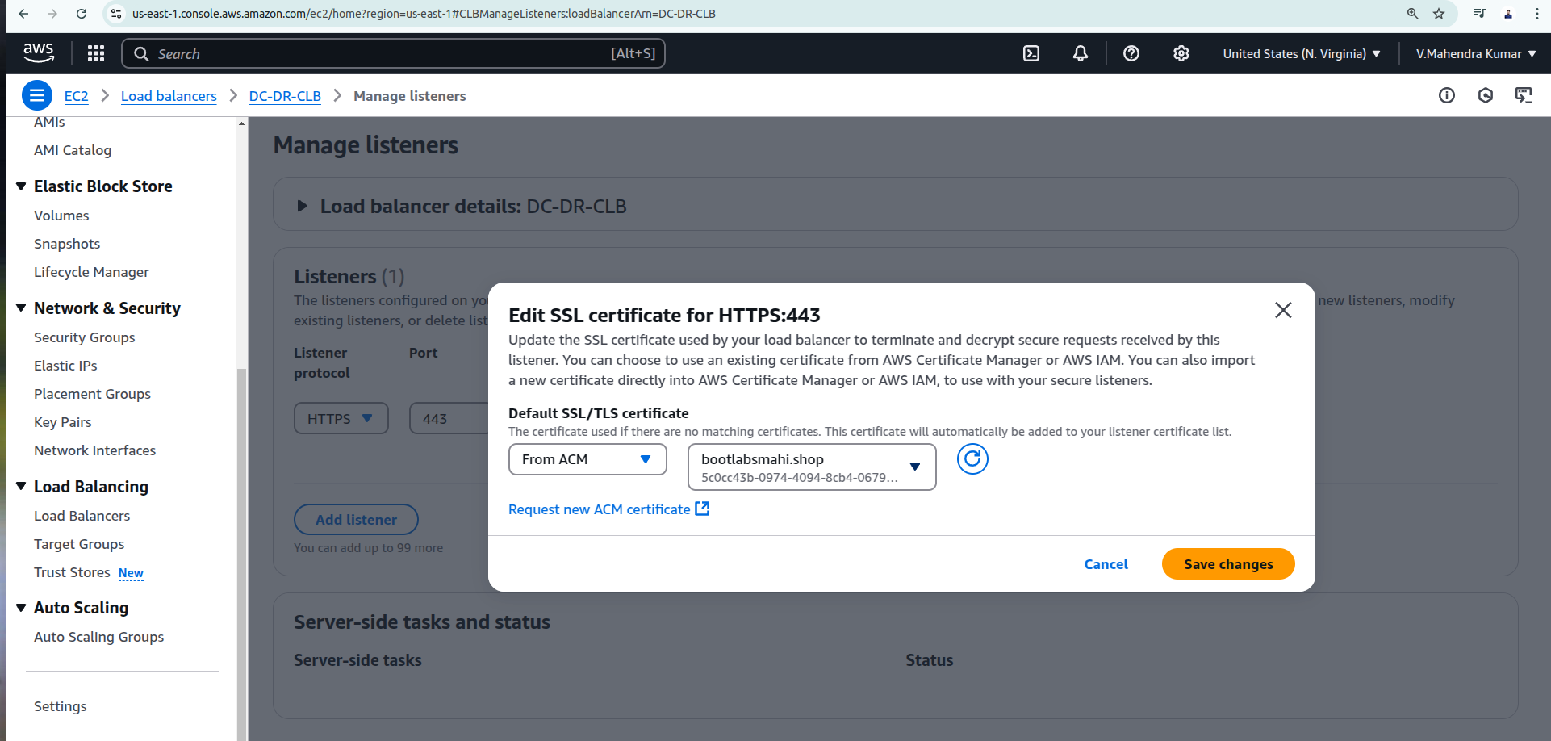

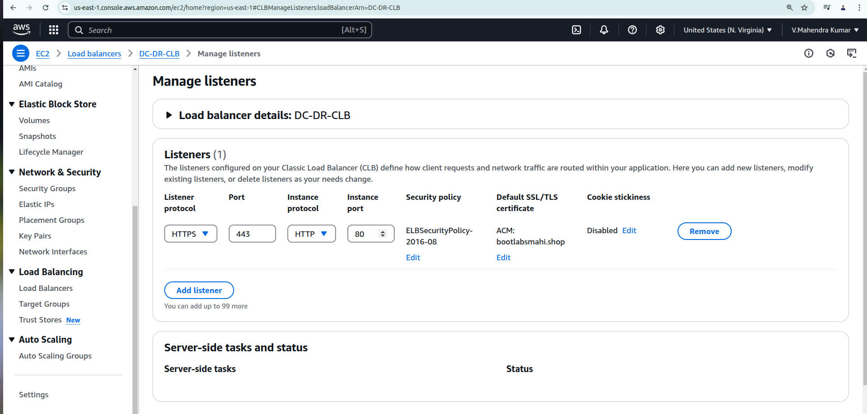

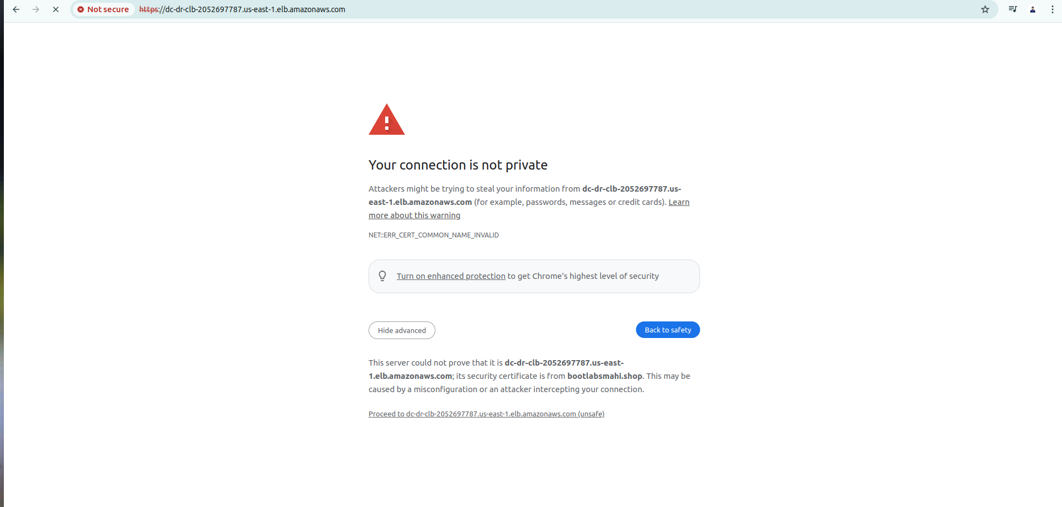

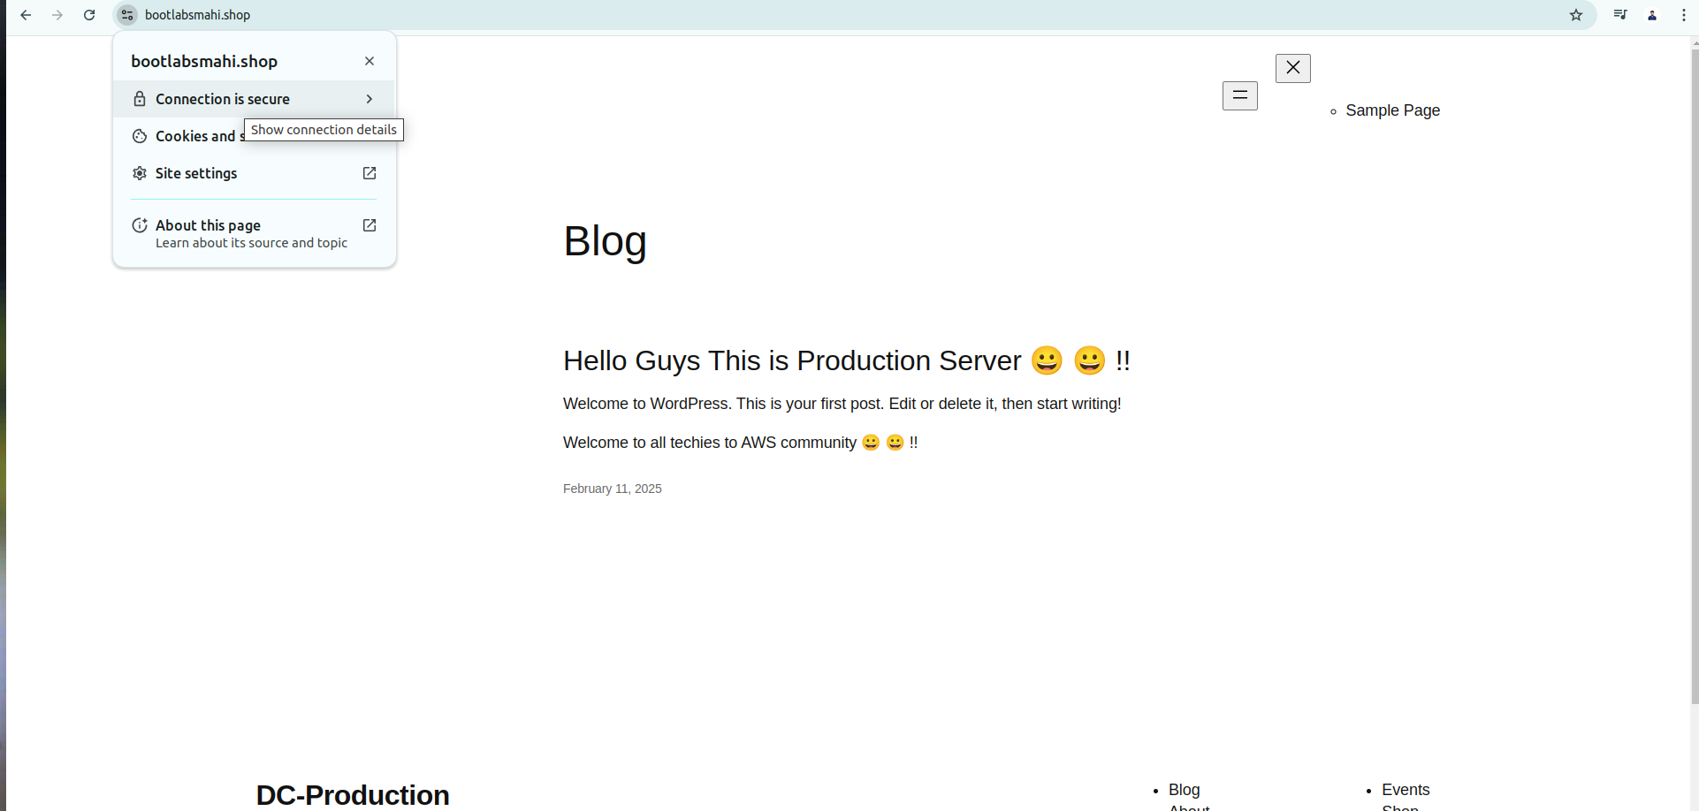

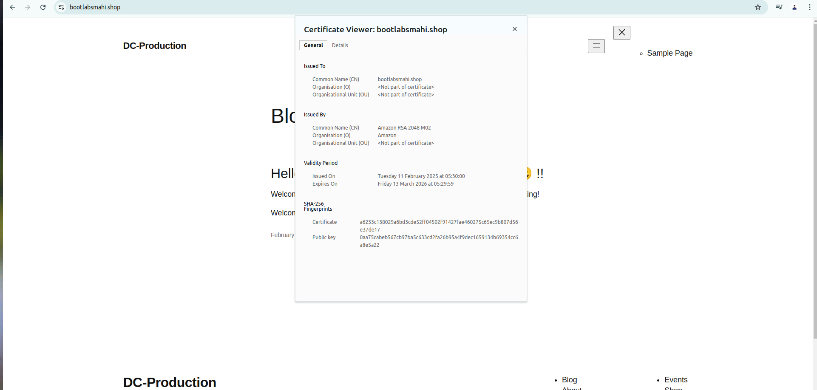

**DR:**

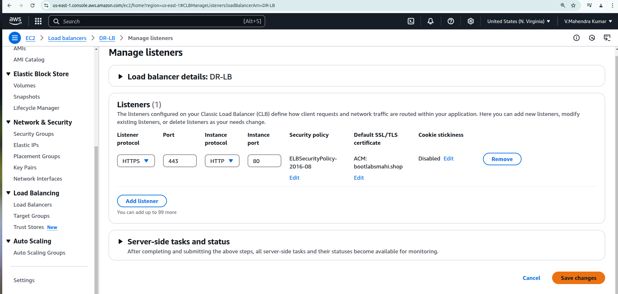

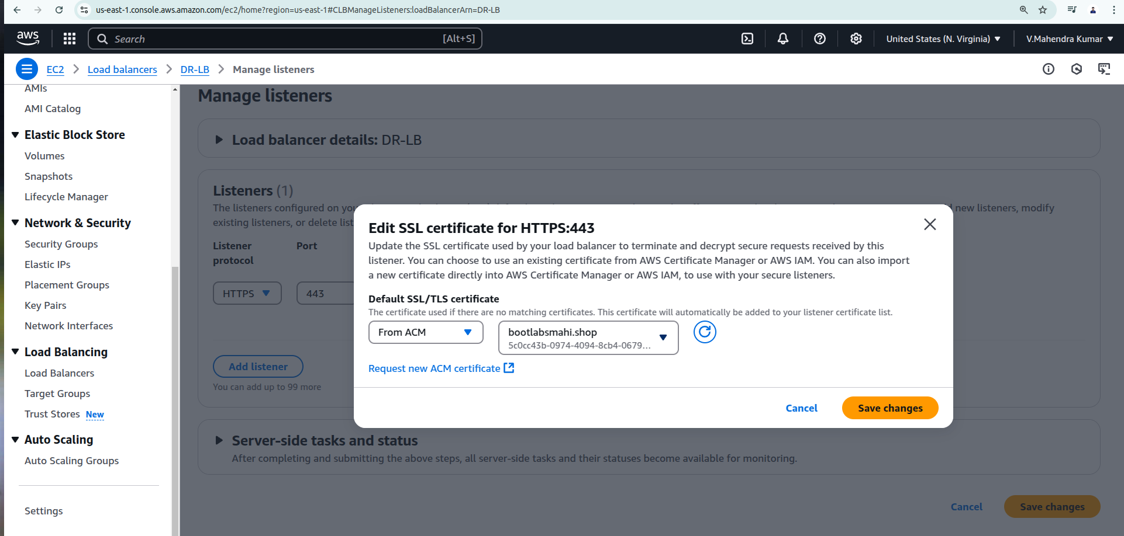

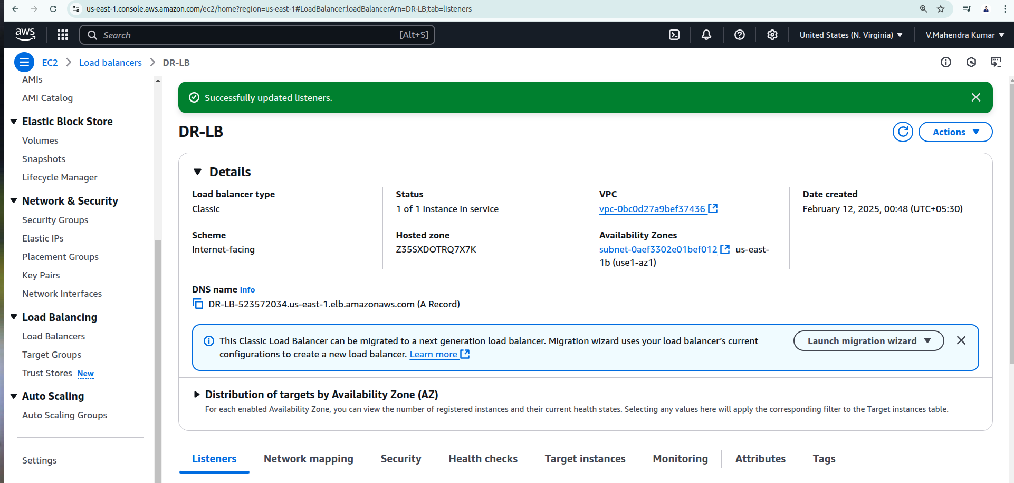

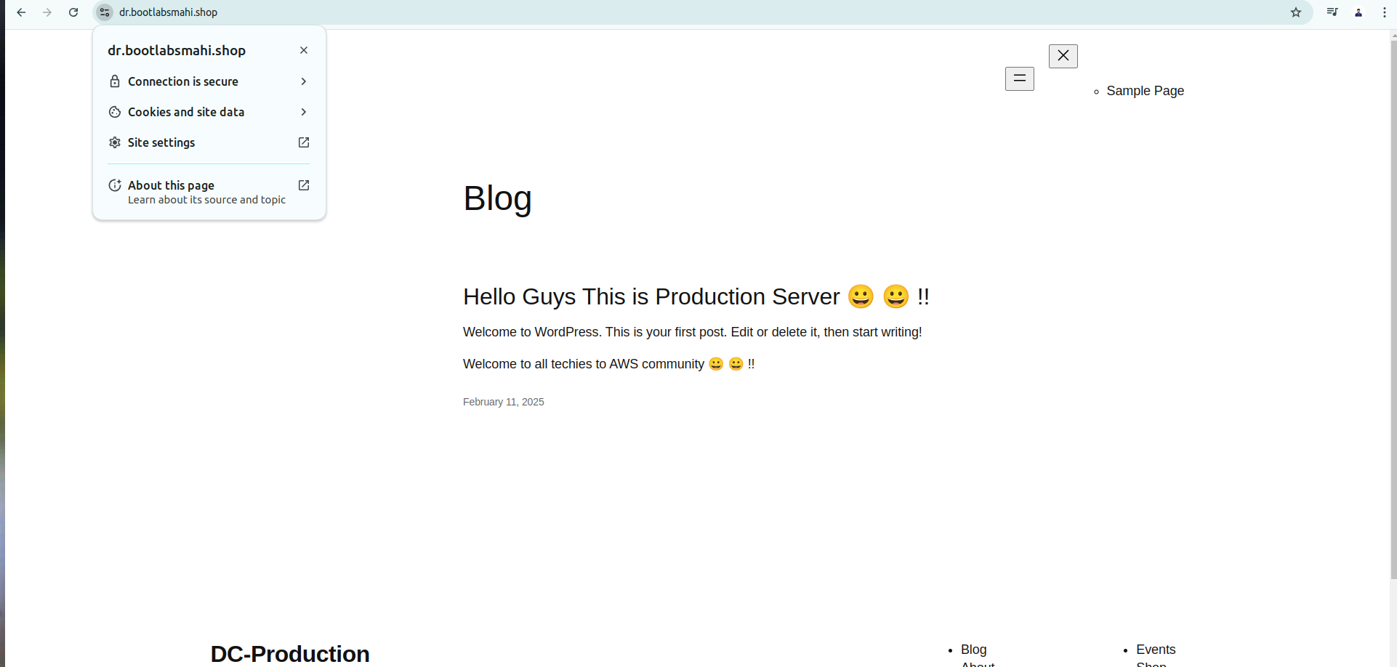

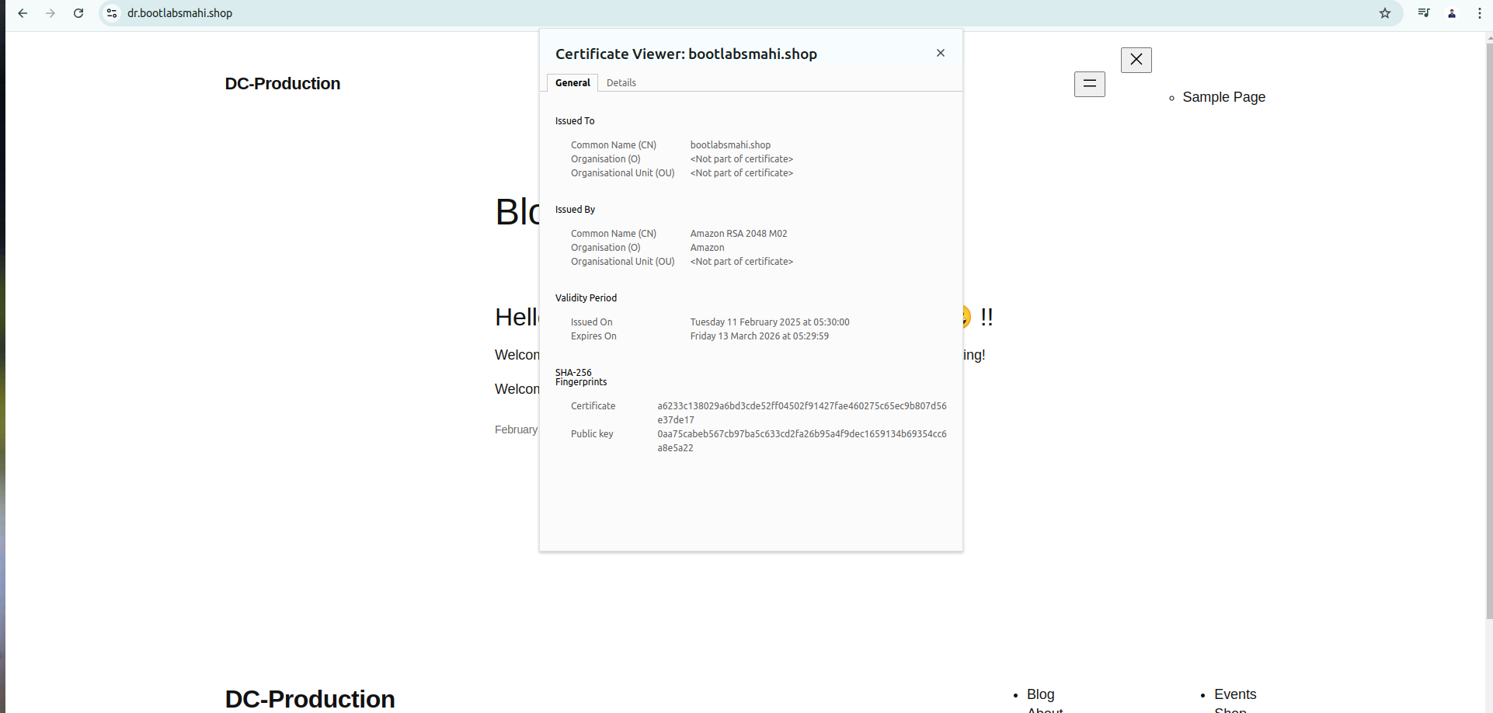

**All The Best**